**Register Here:**

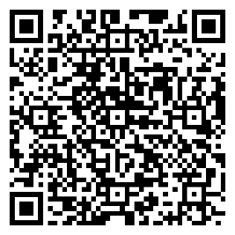

Fall 2025:

Wednesday, October 8th

3:00-4:30 pm

SECC 106

* What does ‘decolonization’ mean?
* What would decolonization look like at WCU?
* What can *we* do to decolonize our syllabi?

This is the first of a two-part workshop for faculty on decolonizing courses at West Chester University. Each session, one taking place in the fall and the other taking place in the spring, will focus on decolonizing a different aspect of our teaching. For the fall we’ll be discussing what it means to decolonize our *syllabi*, as well as methods for doing so.

*Organized and Facilitated by* Dr. Joseph Len Miller (Department of Philosophy)