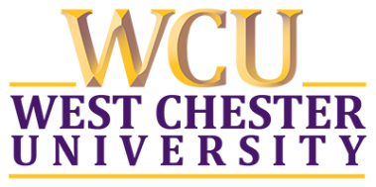
Administrative Program Review

Consistent with PASSHE Board Policy 1986-04-A Program Review, WCU has a local 5-year review process for review of individual administrative units. Self-studies should consist of approximately 5,000 words/10 single-spaced pages, not including appendices. It is suggested that units make use of the standards provided by Council for Advancement of Standards (CAS) or an equivalent set of quality assurance standards provided by another professional association appropriate to the program. The template provided uses the CAS five guiding principles. Units should also complete Appendix A: Program Review Executive Summary.

Division:

Unit Name:

Submission Date:

Department History, Highlights and Recognition

1: Maximizing the Potential of Students and Their Environments: CAS Standards 1 – 4

1) Mission

2) Programs and Services

3) Student Learning, Development, and Success

4) Assessment

5) Demonstrating support of WCU’s strategic commitment to Teaching & Learning and/or Student Experience.

2: Advocating for Diverse, Equitable, and Inclusive Communities: CAS Standard 5

1) Access, Equity, Diversity, Inclusion, and Justice

3: Responsible Organization, Leadership, and Human Resources: CAS Standards 6 – 8

1) Leadership

2) Human Resources

3) Collaboration and Communication

4: Demonstrated Ethical Considerations: CAS Standard 9

1) Ethics, Law, and Policy

5: Proven Learning-Conducive Structures, Resources, and Systems: CAS Standards 10 – 12

1) Financial Resources

2) Technology

3) Facilities and Infrastructure

4) Demonstrating support of WCU’s strategic commitment to Alumni Network and/or Stewards of Place.

6: Unit Future Plans: Please share any other future initiatives you would like to highlight.

