
Wayne Hall

125 W. Rosedale Avenue
Built: 1971 | Size: 92,800 sf
Acquired: N/A | Condition: Fair
Last Renovation: 1992 | Function: AUX

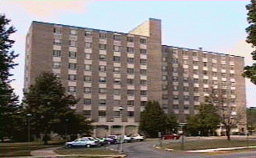

Wayne Hall is a nine-story residence hall that is locaed on West Rosedale Ave between Schmidt and Killinger Halls. The main floor is occupied by a lobby, a bicycle storage room, resident director’s apartment, a resource room, a large recreation room, and a kitchen. The second floor houses the Student Health and Wellness Center

Although having only 26 years of use, Wayne Hall is in need of renovation and upgrade. The structure is scheduled to be demolished in the ear future and replaced with a new suite-style residence hall.

Present Use: Residence Hall. The second floor of the building is used for the Student Health and Wellness Center.

Disability Access: Full

Past Projects: 1992 Renovation, 1994 Roof, 1996- Student Health Center and Business Services Center on 2nd/3rd floors, 1999 Elevator & Emerg generator, 2002 Renovation of 3rd floor from offices to student room use, 2003 Sprinkler and Fire Alarm Upgrades, 2004 Paint and Carpet.

Scheduled Projects or Capital Renovations: Demolition

Description of Construction: Reinforced concrete foundation and structure; built-up roof, masonry brick veneer exterior walls; concrete slab floors.

Condition and Use Assessment:
Deferred Maintenance (2007): N/A | Est Replacement Cost (2007): $ 20,114,000
Facility Condition Index: 0. | Deficiency/SF: $
Yearly Electric Use Cost: $ | Yearly Water Use Cost $

