
Montemuro House

811 Roslyn Avenue
Built: 1950 | Size: 2,517 sf
Acquired: 1964 | Condition: Excellent
Last Renovation: 2000 | Function: E&G

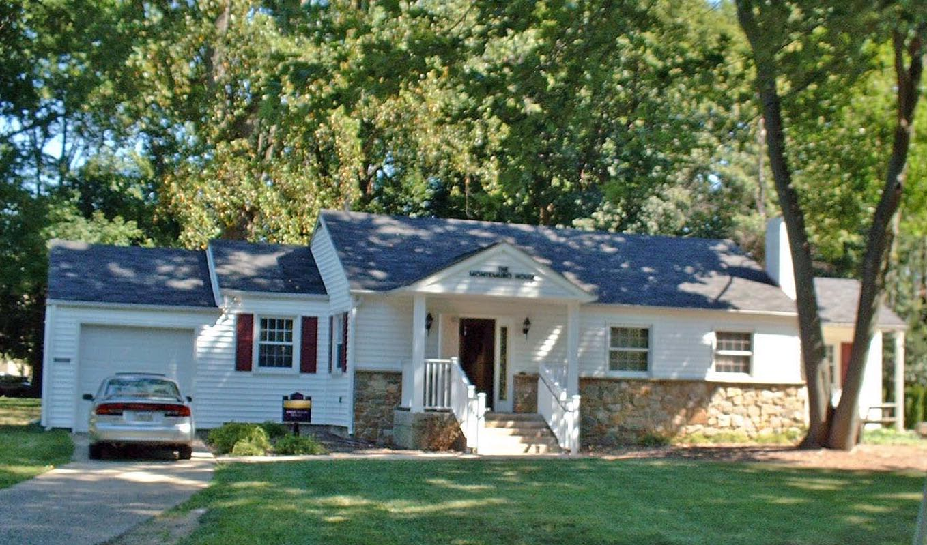

The faculty union (APSCUF) and staff union (AFSCME) are located at 811 Roslyn. The building, a former private residence, has a large backyard that is adjacent to the southwest corner of the Sykes Student Union parking lot. A new partial stone façade and rear ADA ramp was added during the general renovation in 2001.

Present Use: Offices

Disability Access: 1st floor only thru ramp at rear, no basement (storage only)

Past Projects: 2001 Renovation

Scheduled Projects or Capital Renovations: None

Description of Construction: Masonry block foundation, asphalt shingle roof, wood siding on wood frame exterior walls, wood floors.

Condition and Use Assessment:
Deferred Maintenance (2006): $ 0 | Est Replacement Cost (2007): $ 540,000
Facility Condition Index: 0. | Deficiency/SF: $
Yearly Electric Use Cost: $ | Yearly Water Use Cost $

