Residence Halls – Not Operated by the University

University Hall  180 University Avenue  Built: 2004  90,724 sf | 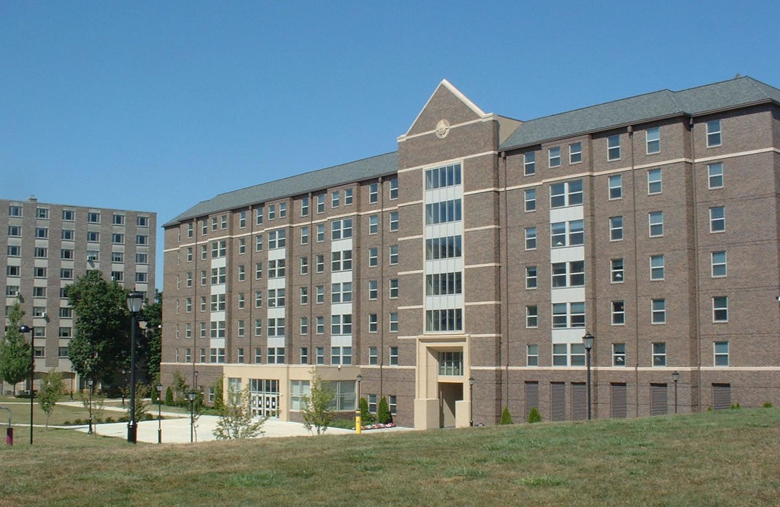
The Village  Bldg # 181 – Clubhouse  181 Carey Drive  Built: 2004  4,814 sf | 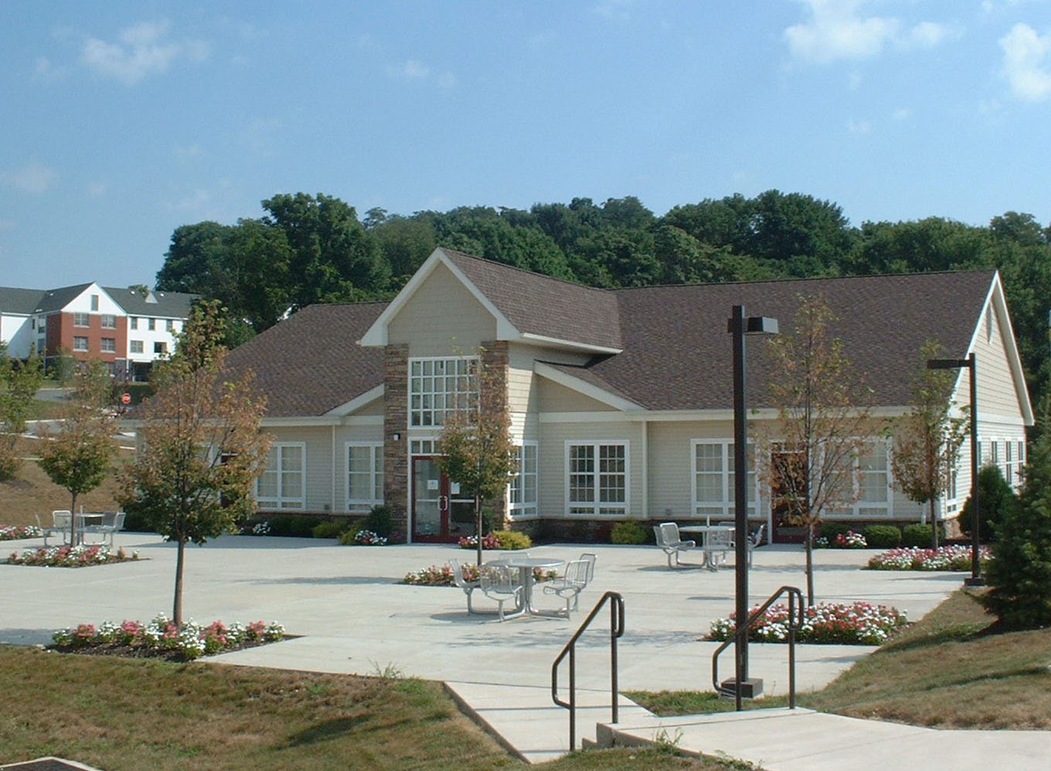
The Village  Bldg # 182  182 Carey Drive  Built: 2004  17,082 sf | 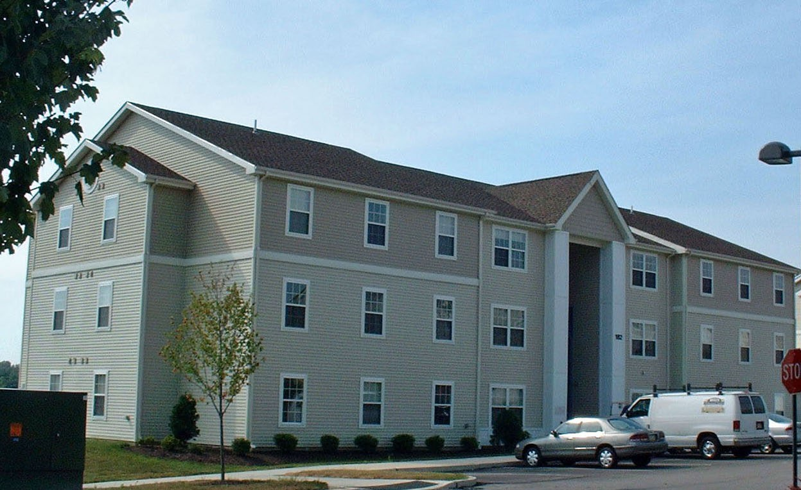
The Village  Bldg # 183  183 Carey Drive  Built: 2004  17,082 sf | 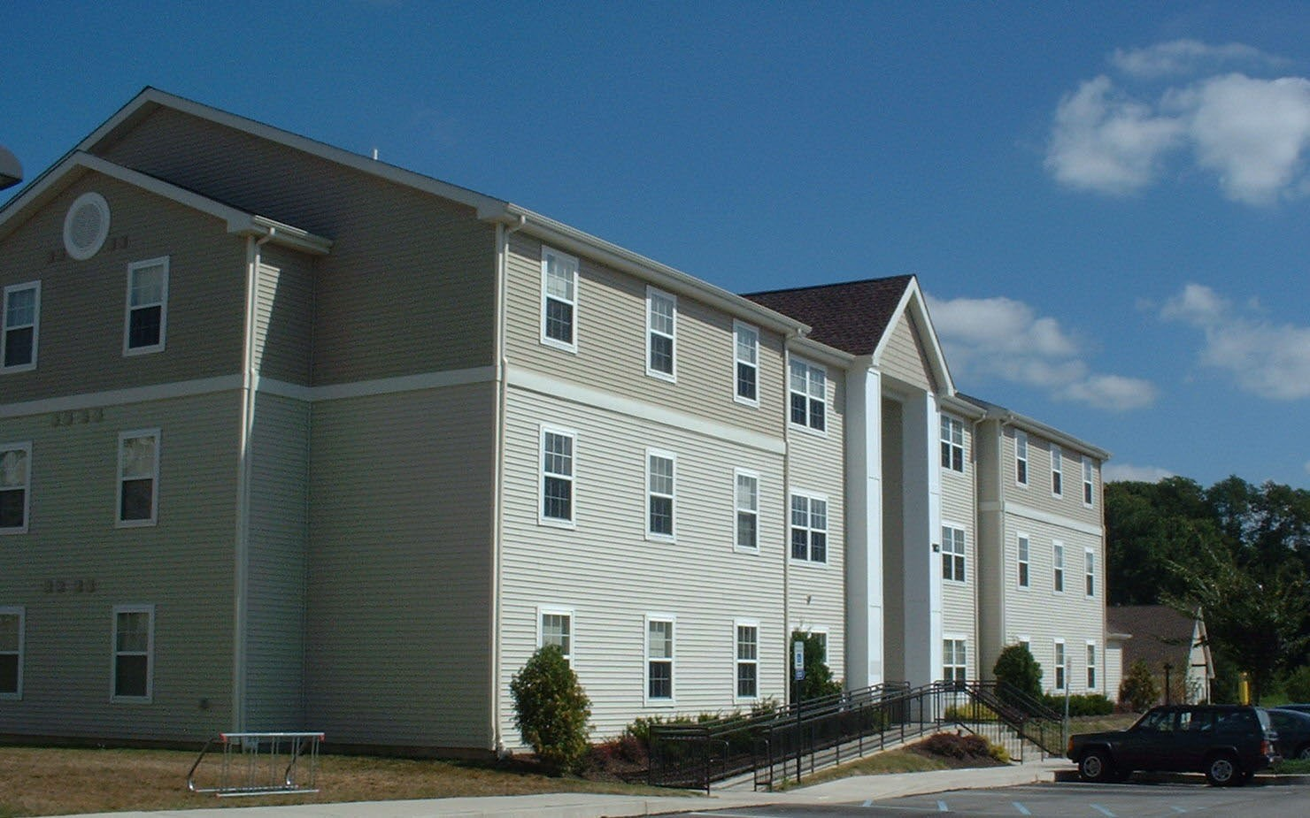
The Village  Bldg # 184  184 Carey Drive  Built: 2004  17,082 sf | 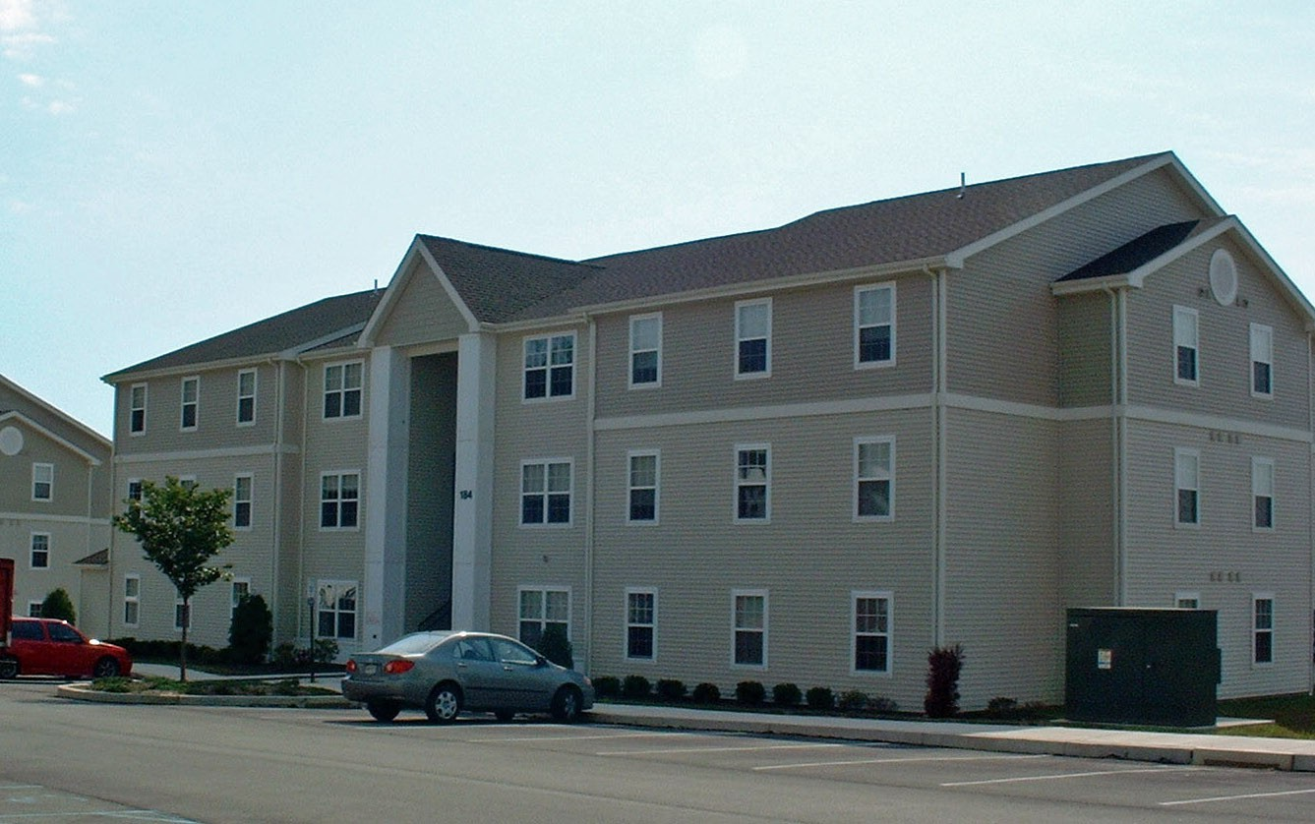
The Village  Bldg # 185  185 Carey Drive  Built: 2004  17,082 sf | 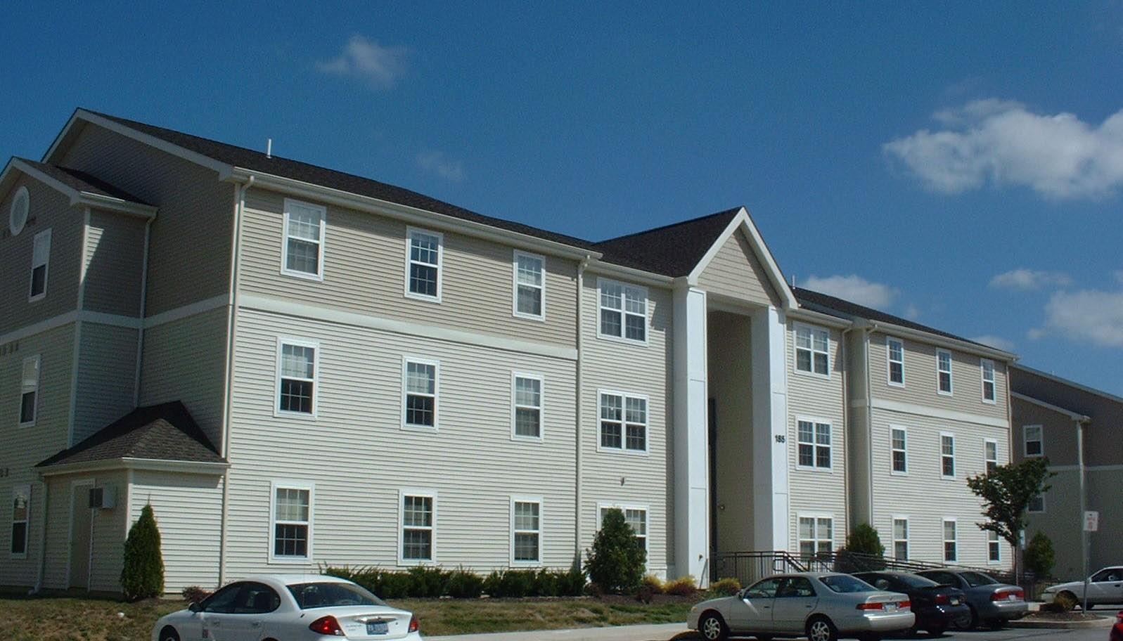
The Village  Bldg # 186  186 Carey Drive  Built: 2004  17,082 sf | 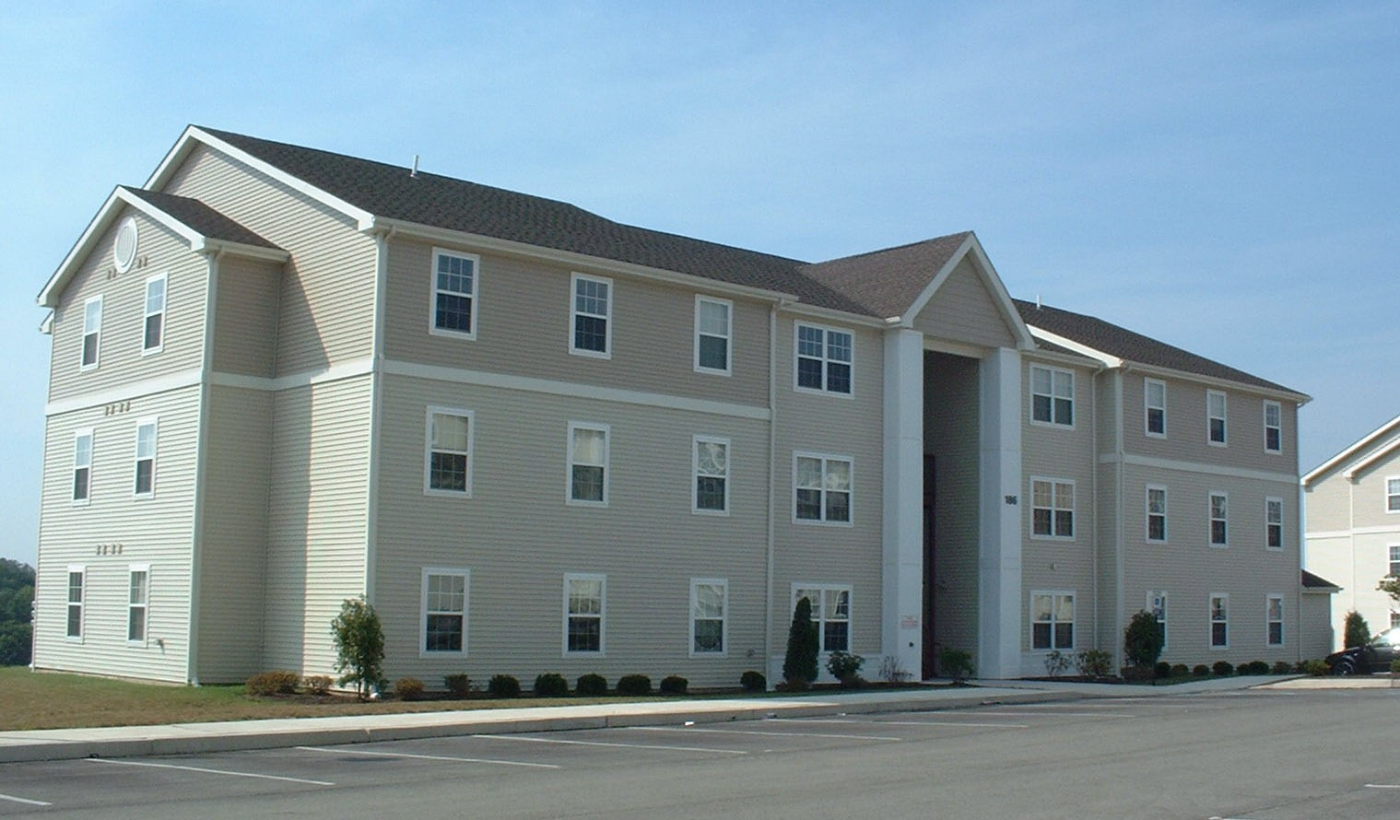
The Village  Bldg # 187  187 Carey Drive  Built: 2004  17,082 sf | 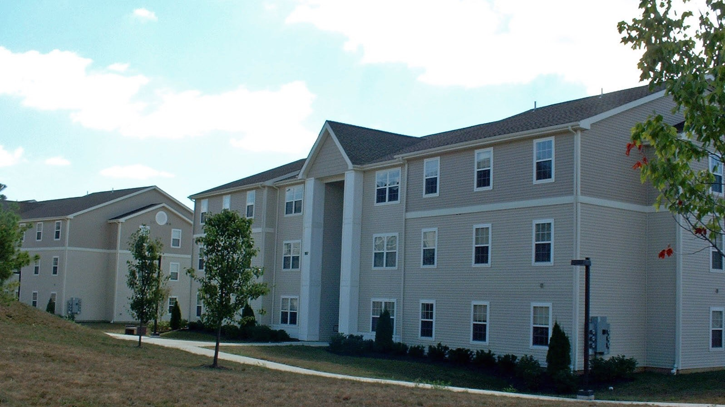
The Village  Bldg # 188  188 Carey Drive  Built: 2004  17,082 sf | 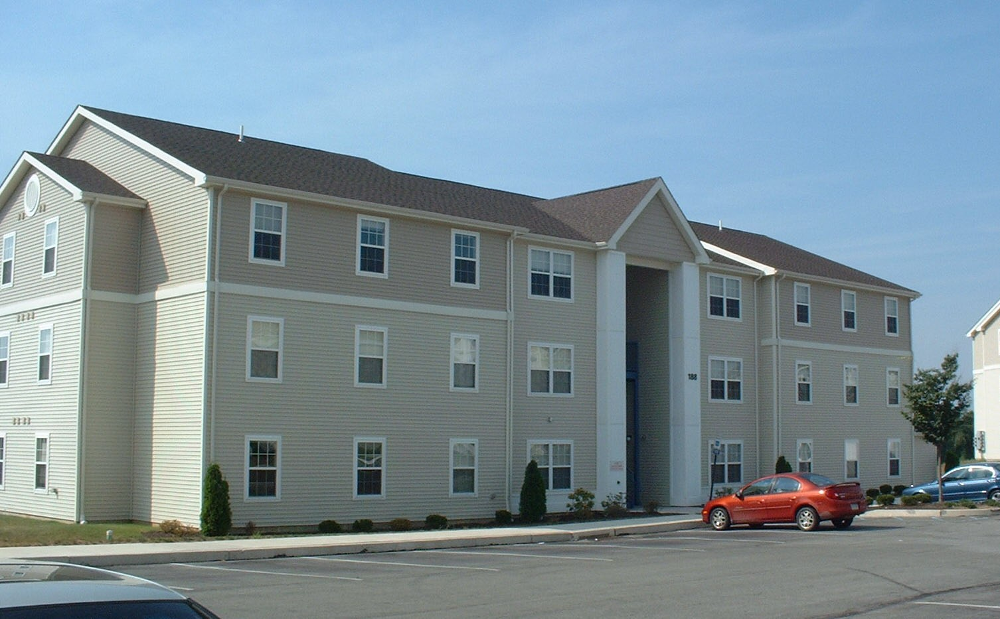
The Village  Bldg # 189 - Maintenance Bldg  189 Carey Drive  Built: 2004 | 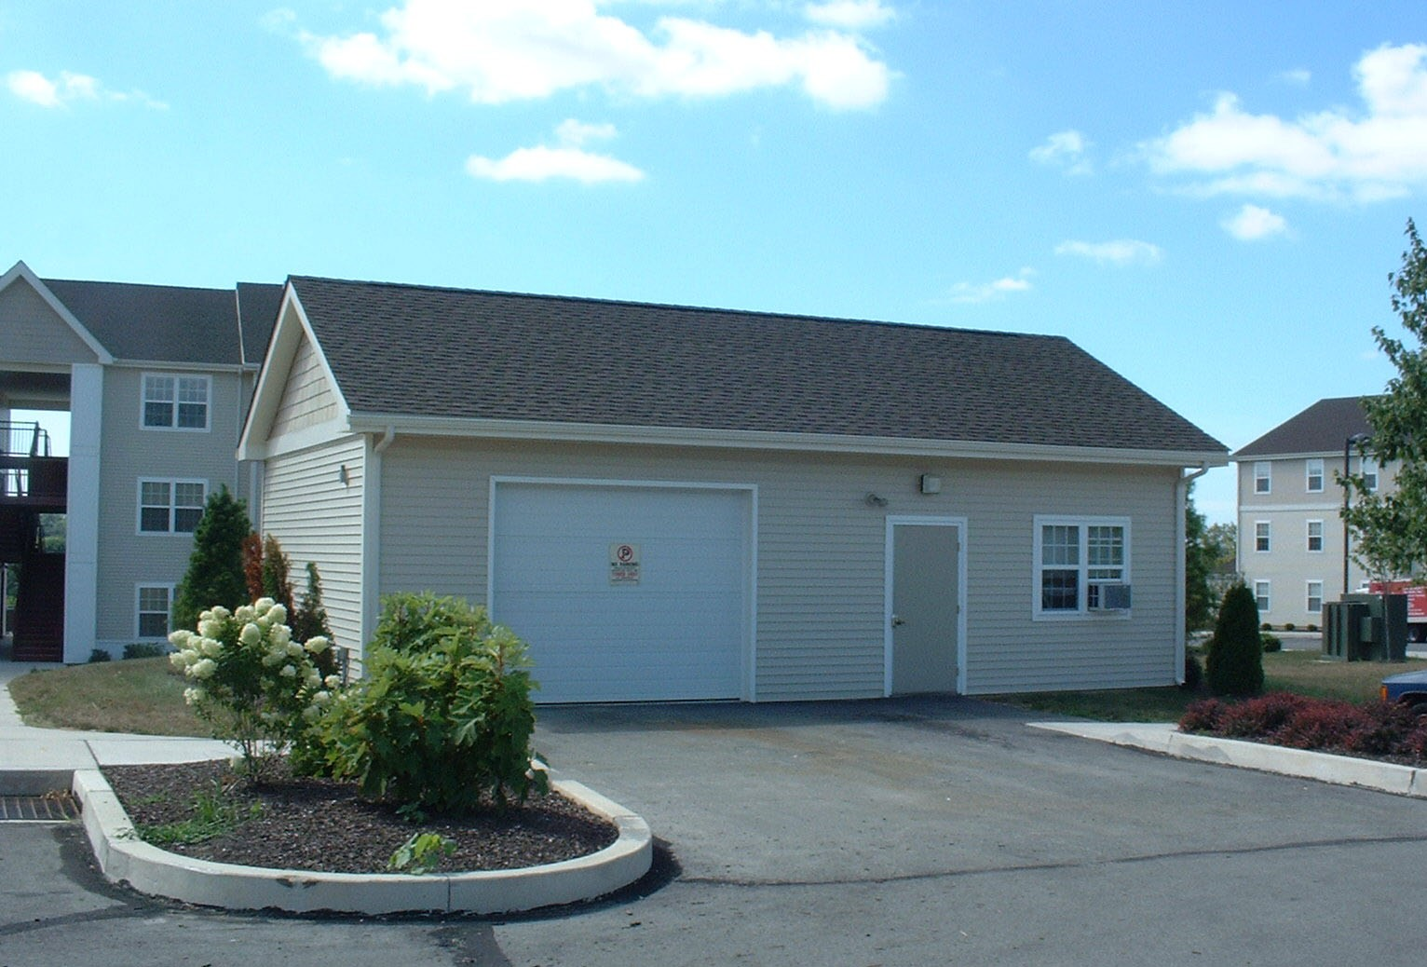
The Village  Bldg # 190  190 Carey Drive  Built: 2004  17,082 sf | 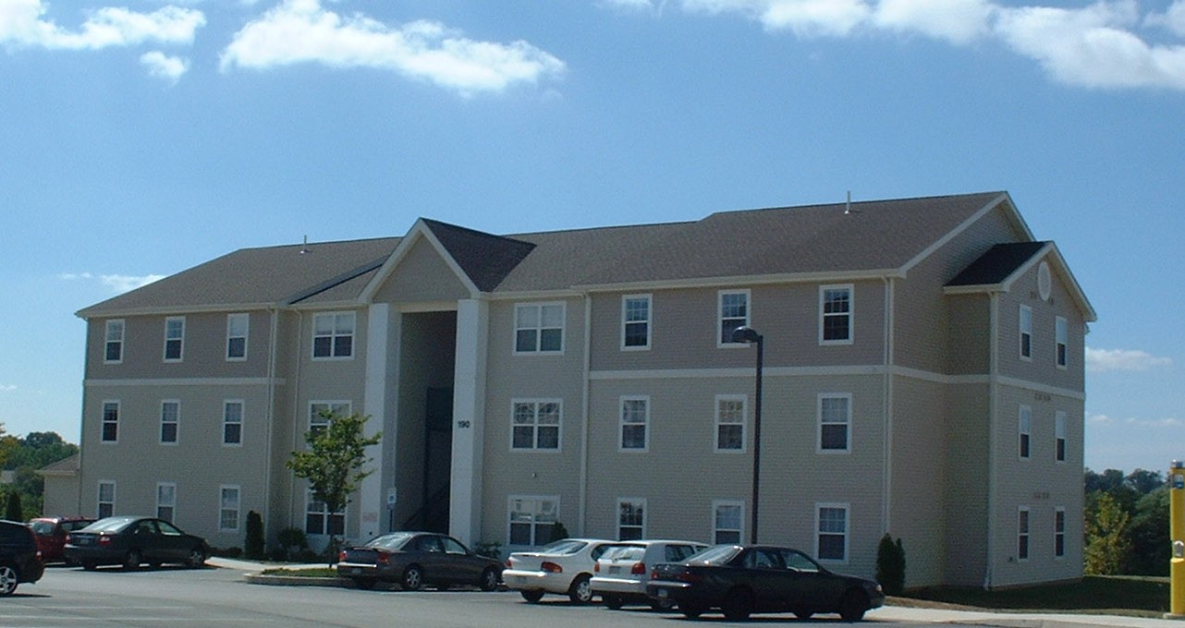
The Village  Bldg # 191  191 Carey Drive  Built: 2004  17,082 sf | 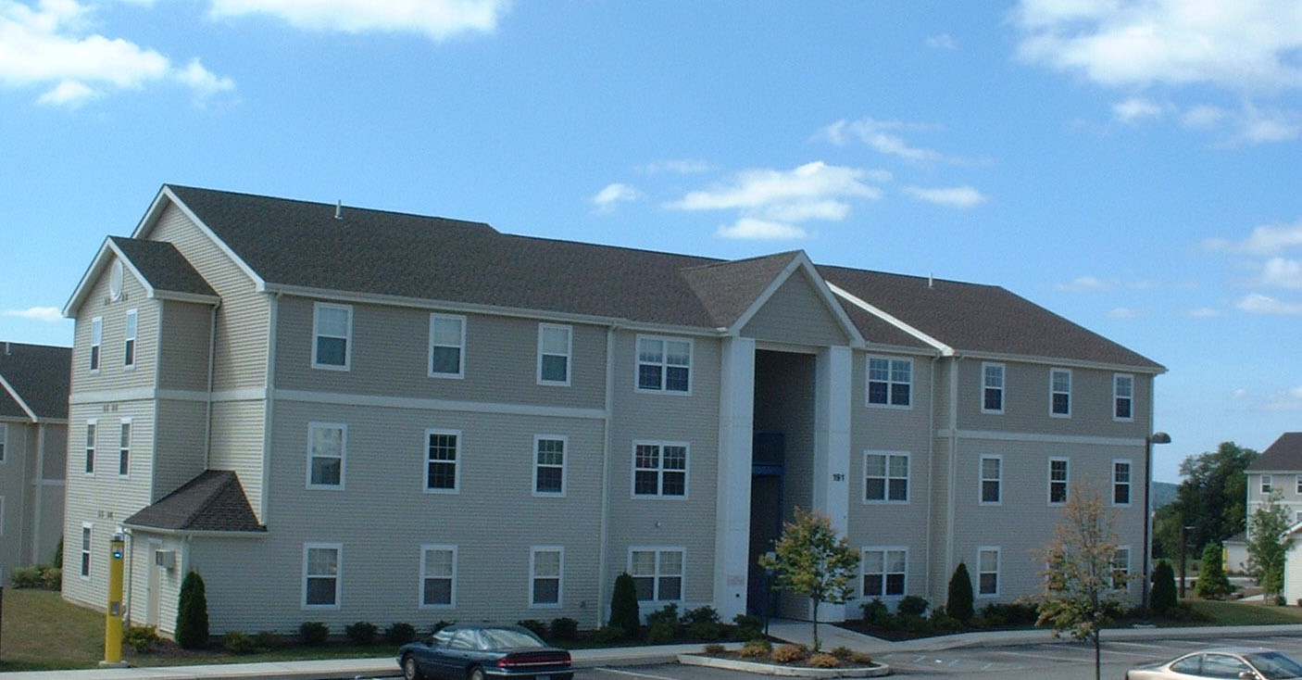
The Village  Bldg # 192  192 Carey Drive  Built: 2004  17,082 sf | 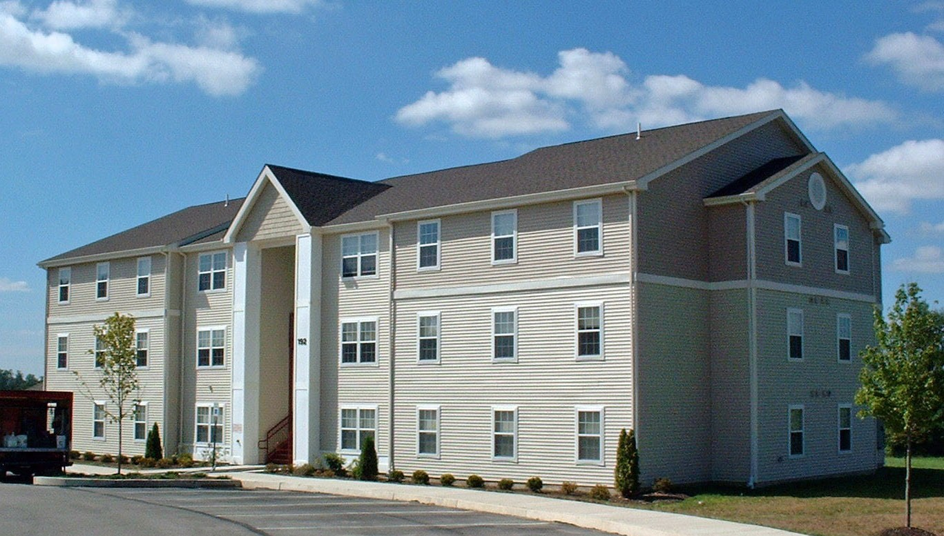
The Village  Bldg # 193  193 Carey Drive  Built: 2004  17,082 sf | 