
Tanglewood

100 E. Rosedale Avenue
Built: 1787 | Size: 10,383 sf
Acquired: 1916 | Condition: Good
Last Renovation: 1998 | Function: E&G

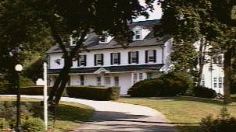

Tanglewood is in good condition. Although the house is large, it lacks several essential features required for a President’s residence, including outdoor entertainment areas, a more suitable entrance, improved handicapped accessibility, and improved HVAC.

Present Use: President’s Residence (since 1930)

Disability Access: Ground floor only.

Past Projects: 1984 Roof, 1998 Site/Utilities

Scheduled Projects or Capital Renovations: None

Description of Construction: Masonry stone foundation, asphalt shingle roof/dormers, masonry stucco exterior walls, wood floors.

Condition and Use Assessment:
Deferred Maintenance (2007): $ 200,000 | Est Replacement Cost (2007): $ 2,178,000
Facility Condition Index: 0.09 | Deficiency/SF: $ 19.26
Yearly Electric Use Cost: $ | Yearly Water Use Cost $

