
Tanglewood Garage

100 E. Rosedale Avenue
Built: 1787 | Size: 2,660 sf
Acquired: 1891 | Condition: Fair
Last Renovation: | Function: E&G

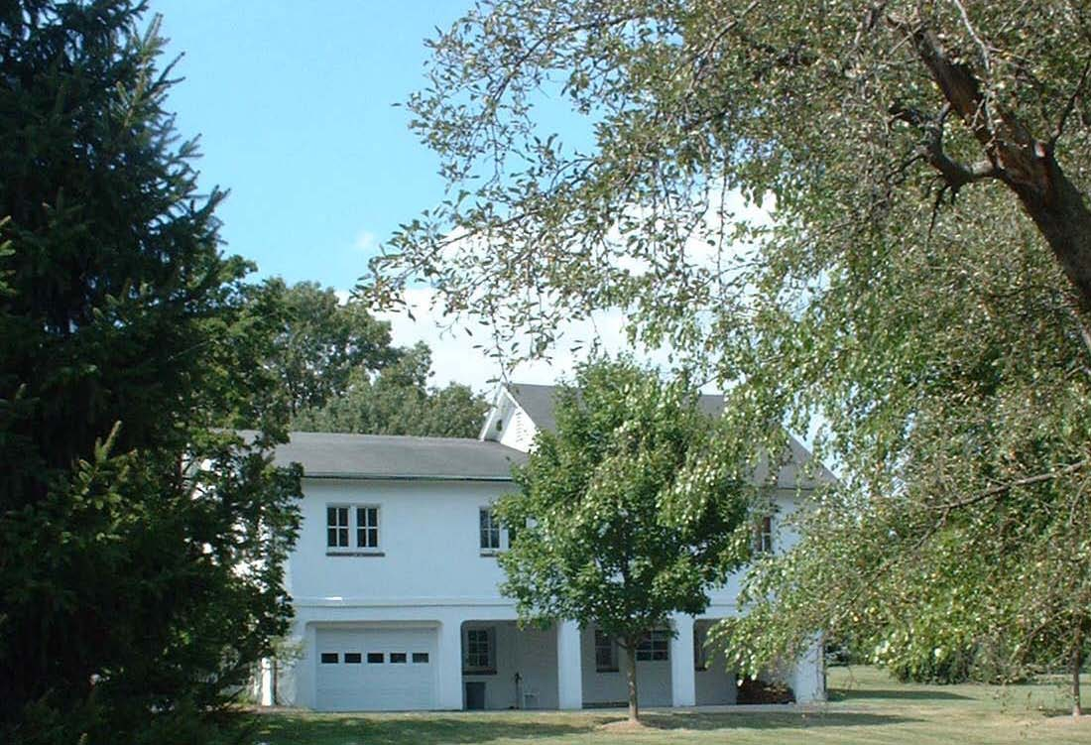

The Tanglewood garage is utilized for garage purposes, as well as Theater Department storage.

Present Use: Garage & Storage

Disability Access: Full, grade entrances at both levels.

Past Projects: 1987- Roof replacement

Scheduled Projects or Capital Renovations: None

Description of Construction: Masonry stone foundation, wood frame with wood siding exterior walls, wood shingle roof, wood and concrete floors.

Condition and Use Assessment:
Deferred Maintenance (2007): $ | Est Replacement Cost (2007): $
Facility Condition Index: 0. | Deficiency/SF: $
Yearly Electric Use Cost: $ | Yearly Water Use Cost $

