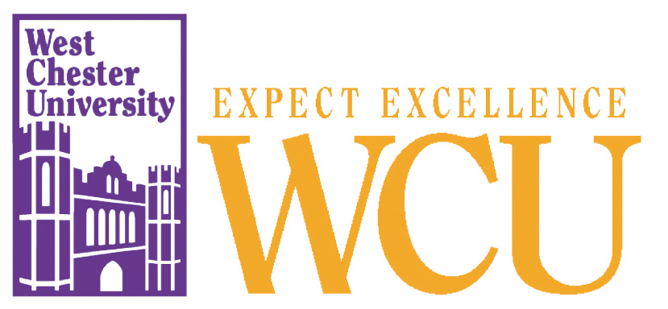
Sykes Student Union

110 W. Rosedale Avenue
Built: 1975 | Size: 105,004 sf
Acquired: N/A | Condition: Good
Last Renovation: 1995 | Function: AUX
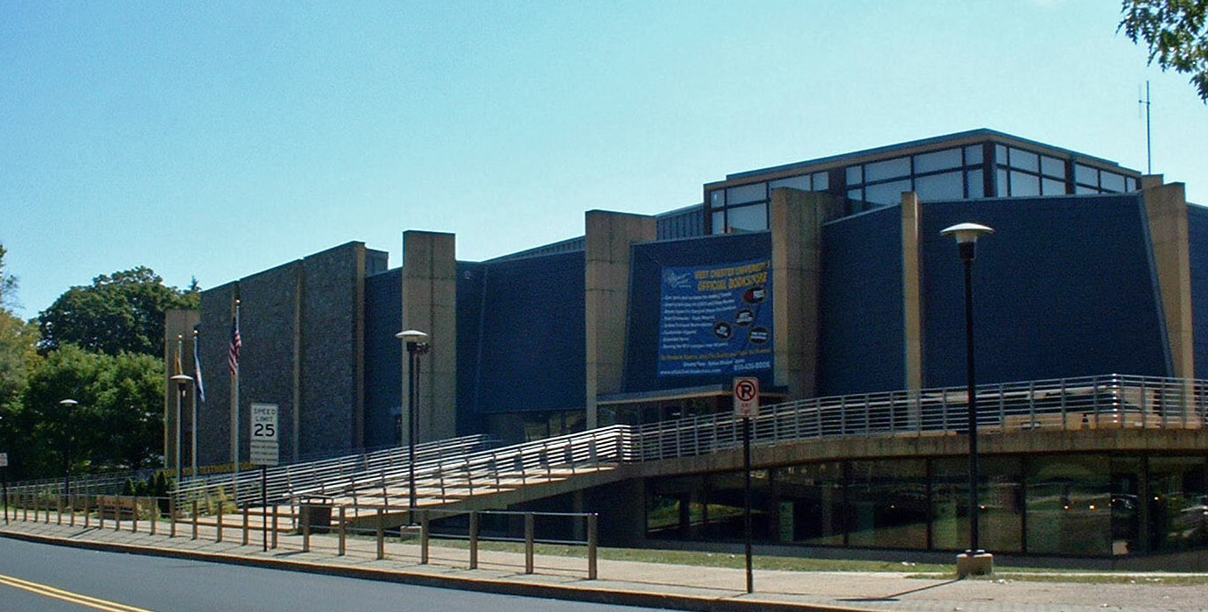
The Sykes Student Union building is the hub of student life and is prominently located on West Rosedale Avenue near South Church Street. The original 1975 building underwent a massive renovation and addition in 1995, which resulted in a building that is new and exciting with great public
spaces and an abundance of natural light.

The addition of 38,000 square feet of space provided for a large expansion of the book store and deli area, a fitness center, additional conference rooms, and a large multi-purpose room divisible into three conference rooms. Life cycle repairs are continuing under a sinking fund that has accrued from a portion of student fees.

Funding for the expansion and renovation of Sykes Student Union was covered by a bond. Debt service is paid by a student activity fee. The expanded facility has become a hub of student activities throughout the day and well into the evening. Custodial and maintenance services have been enhanced to ensure a quality facility is maintained.
Present Use: Offices, bookstore, lounges, computer center, deli, conference rooms, fitness center, passive recreation areas.

Disability Access: Full, with front ramp and grade access at western entrance near accessible parking.

Past Projects: 1995 Life-cycle Renovation, 1996 Roof, 2006 Humidity control in Theatre.

Scheduled Projects or Capital Renovations: None

Description of Construction: Reinforced concrete foundation, built-up roof, masonry brick veneer and slate exterior walls, concrete slab floors.

Condition and Use Assessment:
Deferred Maintenance (2007): $ 0 | Est Replacement Cost (2007): $ 24,403,000
Facility Condition Index: 0. | Deficiency/SF: $
Yearly Electric Use Cost: $ | Yearly Water Use Cost $

