
114 W. Rosedale Avenue

114 W. Rosedale Avenue
Built: 1950s | Size: 3,267 sf
Acquired: 1990 | Condition: Good
Last Renovation: 2001 | Function: E&G

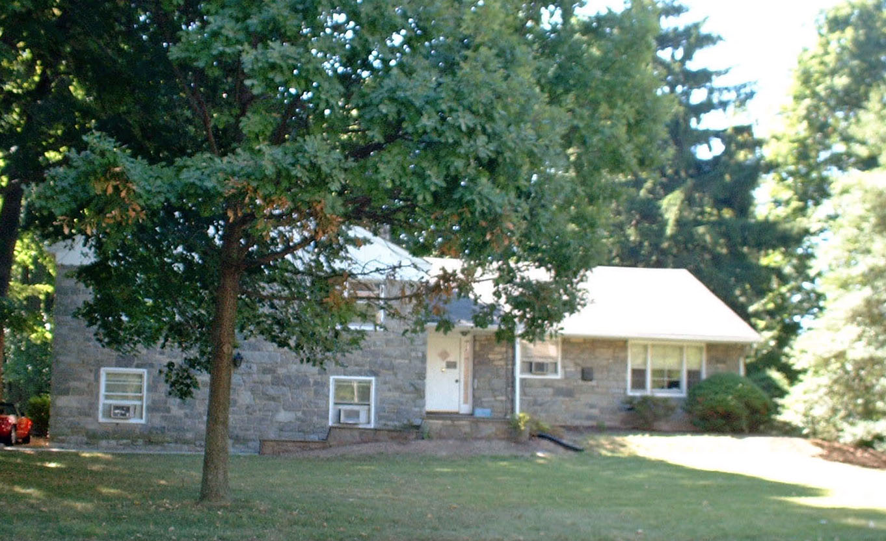

114 Rosedale is currently utilized by the Undergraduate Social Work Department.

Present Use: Undergraduate Social Work Dept.

Disability Access: Ground floor meeting room and restroom.

Past Projects: 1991- General, 2001 ADA Entrance/Bathroom

Scheduled Projects or Capital Renovations:

Description of Construction: Masonry block foundation, asphalt shingle roof, stone on wood frame exterior walls, wood floor.

Condition and Use Assessment:
Deferred Maintenance (2007): $ 33,500 | Est Replacement Cost (2007): $ 701,000
Facility Condition Index: 0.047 | Deficiency/SF: $ 10.25
Yearly Electric Use Cost: $ | Yearly Water Use Cost $

