
Schmucker Science Center - South

750 S. Church Street
Built: 1968 | Size: 75,226 sf
Acquired: N/A | Condition: Excellent
Last Renovation: 2000 | Function: E&G

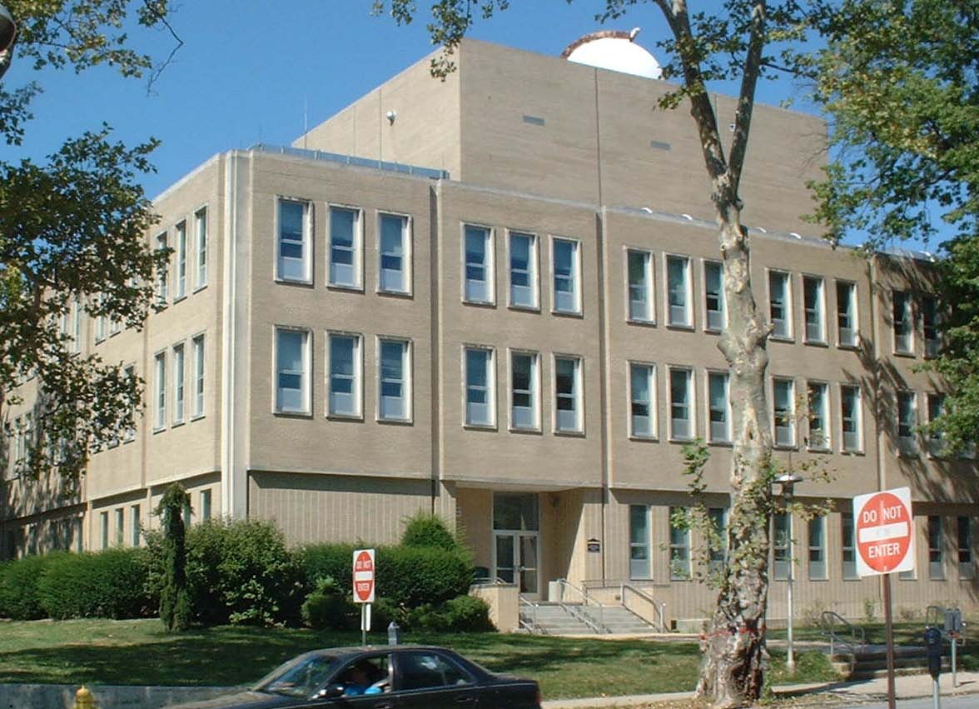
The Schmucker Science Center, Phases I & II, consists of two buildings: SSC North, built in 1965, and SSC South, built in 1968. The buildings are located on South Church Street near the intersection of Rosedale Avenue. The Center houses an observatory and planetarium, as well as offices, laboratories, and faculty research spaces. SSC South recently underwent a major renovation in 2000 that brought classrooms, laboratories, and offices up
to professional standards. SSC North has also now undergone total renovation, with
work completed in January 2004.

TThe Chemistry, and Geology and Astronomy Departments moved back into SSC South in the fall of 2000. Modern, well-equipped laboratories and research spaces greatly enhance teaching and learning. Private, quality faculty offices provide a quantum improvement from previous overcrowded spaces. New furnishings were provided throughout. The renovation includes an Electron Microscopy Suite and Material Research Center, partially funded through National Science Foundation Academic Infrastructure grants of nearly $1 million.

Present Use: Science laboratories, classrooms, and offices

Disability Access: Full, via ramp at front door.

Past Projects: 1999 Roof, 2000 Renovation

Scheduled Projects or Capital Renovations: Renovation of SSC South, $12,100,000, was approved in the FY 90/91 capital budget program and completed in 2000.

Description of Construction: Reinforced concrete foundation, built-up roof, masonry brick veneer exterior walls, concrete slab floors.

Condition and Use Assessment:
Deferred Maintenance (2007): $ 0 | Est Replacement Cost (2007): $ 23,135,000
Facility Condition Index: 0. | Deficiency/SF: $
Yearly Electric Use Cost: $ | Yearly Water Use Cost $

