
Schmucker Science Center - North

730 S. Church Street
Built: 1965 | Size: 49,287 sf
Acquired: N/A | Condition: Excellent
Last Renovation: 2003 | Function: E&G

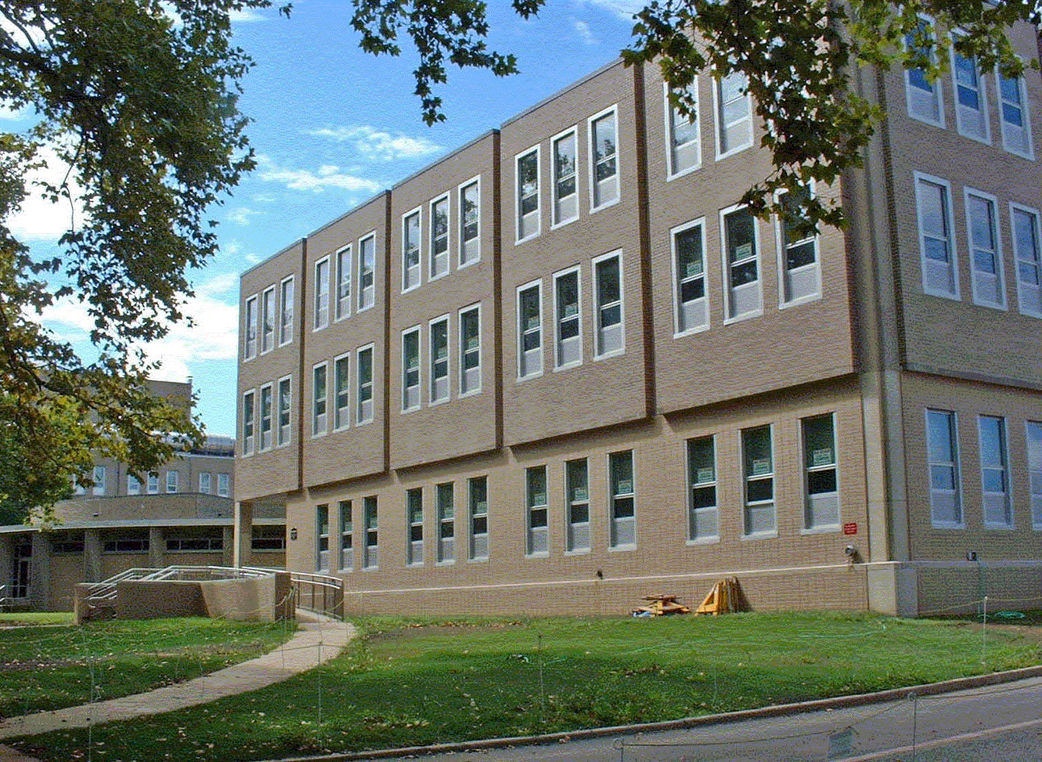

The Schmucker Science Center, Phases I & II, consists of two buildings: SSC - North, built in 1965, and SSC - South, built in 1968. The buildings are located across the street from Anderson Hall on South Church Street. The Center houses, among other assets, the observatory and planetarium. SSC - South underwent a major renovation completed in 2000 that brought classrooms, laboratories, and offices up to professional standards. SSC - North and SSC-Link has undergone the same treatment in 2003, including a 4,650 sf building addition that houses three new lecture halls.

The science center now houses virtually all facilities for the Biology, Chemistry, and Geology/Astronomy Departments.
Schmucker Science Center North houses the Darlington Herbarium, one of the most highly regarded historical collections of dried plant specimens in the East.

Present Use: Academic classrooms, laboratories, faculty research and office space, staff offices, lecture hall, animal facility, and greenhouse.

Disability Access: Full, via ramps at front entrance.

Past Projects: 2003 Renovation

Scheduled Projects or Capital Renovations: Renovation of Schmucker Science Ctr. North commenced in 2002 for $15,842,000, and was completed in 2003.

Description of Construction: Reinforced concrete foundation, built-up roof, masonry brick veneer exterior walls, concrete slab floors.

Condition and Use Assessment:
Deferred Maintenance (2007): $ 0 | Est Replacement Cost (2007): $ 14,599,000
Facility Condition Index: 0. | Deficiency/SF: $
Yearly Electric Use Cost: $ | Yearly Water Use Cost $

