
Schmucker Science Center - Link

750 S. Church Street
Built: 1965 | Size: 20,497 sf
Acquired: N/A | Condition: Excellent
Last Renovation: 2003 | Function: E&G

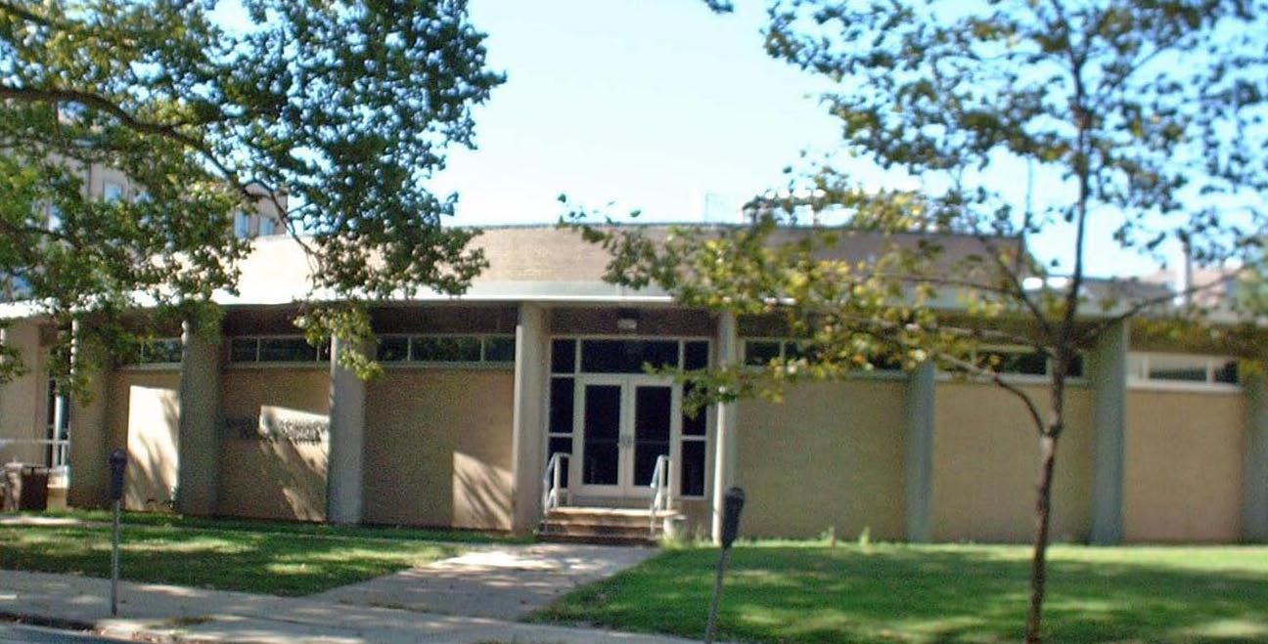
The Schmucker Science Center, Phases I & II, consists of two buildings: SSC - North, built in 1965, and SSC - South, built in 1968, with the connecting Link Building . The buildings are located across the street from Anderson Hall on South Church Street. The Center houses, among other assets, the observatory and planetarium. SSC - South underwent a major renovation completed in 2000 that brought classrooms, laboratories, and offices up to professional standards. SSC - North and SSC-Link completed a similar renovation in 2005. The center now houses virtually all facilities for the Biology, Chemistry, and Geology/Astronomy Departments. Schmucker Science Center link houses the WCU Geology Museum, with several collections of historical and scientific importance.

Present Use: Lecture Hall, Planetarium, Classrooms, receiving and support areas.

Disability Access: Full

Past Projects: 2003 Life Cycle Renovation

Scheduled Projects or Capital Renovations: None

Description of Construction: Reinforced concrete foundation, built-up roof, masonry brick veneer exterior walls, concrete slab floors.

Condition and Use Assessment:
Deferred Maintenance (2007): $ 0 | Est Replacement Cost (2007): see SSS
Facility Condition Index: 0. | Deficiency/SF: $
Yearly Electric Use Cost: $ | Yearly Water Use Cost $

