
Speakman Building

155 University Avenue
Built: 1938 | Size: 7,350 sf
Acquired: N/A | Condition: Good
Last Renovation: 1993 (Partial) | Function: E&G

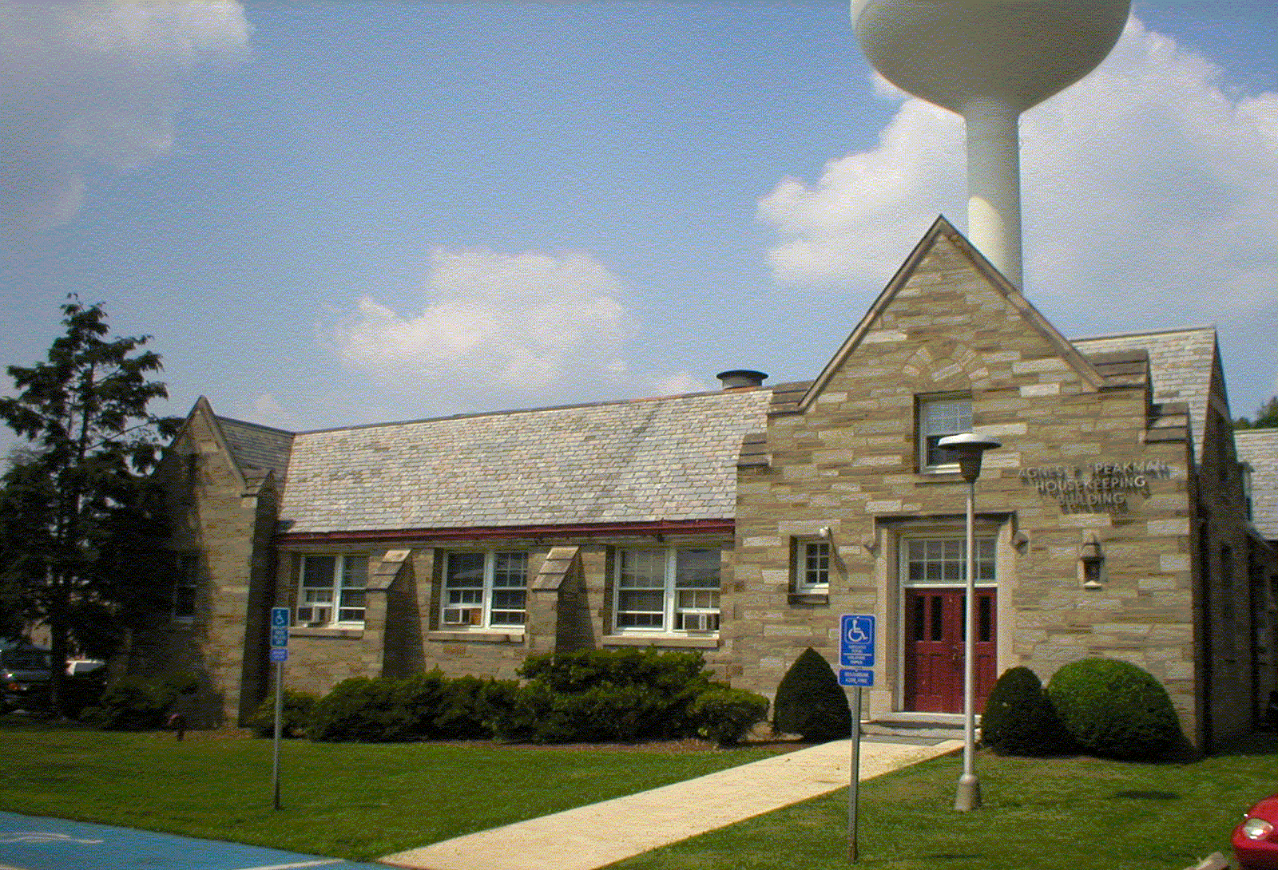

The Agnes F. Speakman Housekeeping Building is a small, two-story Neo-Gothic structure that has the appearance of a private residence. Built in 1938, it is located within the center of the campus, next to the Boiler Plant along University Avenue.

The building currently houses the University's Custodial Services Department.

Present Use: Custodial Services Department

Disability Access: 1st floor only

Past Projects: 1993 Partial Renovation, 1996 Roof, 2002 Fire Alarm

Scheduled Projects or Capital Renovations: Demolition

Description of Construction: Concrete foundation, masonry stone exterior walls, concrete floor, slate shingle roof.

Condition and Use Assessment:
Deferred Maintenance (2007): N/A | Est Replacement Cost (2007): $ 1,517,000
Facility Condition Index: 0. | Deficiency/SF: $
Yearly Electric Use Cost: $ | Yearly Water Use Cost $

