
Schmidt Hall

225 W. Rosedale Avenue
Built: 1971 | Size: 90,720 sf
Acquired: N/A | Condition: Fair
Last Renovation: 1995 | Function: AUX

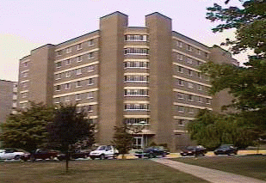

This eight story residence hall building is located at the corner of W. Rosedale Ave and South New St. Amenities include a laundry room and bicycle storage room in the basement, a large newly refurbished recreation room, a kitchen for student’s use, a computer lab and lounge on each floor.

Schmidt Hall is scheduled to be replaced with a suite-style residence hall structure in the near future, along with six other residence hall structures on campus.

Present Use: Residence Hall

Disability Access: Full, with exception of south 1st floor wing, separated by a half set of stairs.

Past Projects: 1995 Asbestos/Carpet/Elevator/Furniture, 2001 Roof, 2003- LAN/ Telephone/ CATV . 2004-Sprinkler and Fire Alarm upgrades.2005- Paint and carpet upgrades.

Scheduled Projects or Capital Renovations: None

Description of Construction: Reinforced concrete foundation and structure, built-up roof, masonry brick veneer exterior walls, concrete slab floors.

Condition and Use Assessment:
Deferred Maintenance (2007): N/A | Est Replacement Cost (2007): $ 18,294,000
Facility Condition Index: 0. | Deficiency/SF: $
Yearly Electric Use Cost: $ | Yearly Water Use Cost $

