
Swope Music Building and the Performing Arts Center

817 S. High Street
Built: 2006 | Size: 87,786 gsf
Acquired: N/A | Condition: Excellent
Last Renovation: | Function: E&G

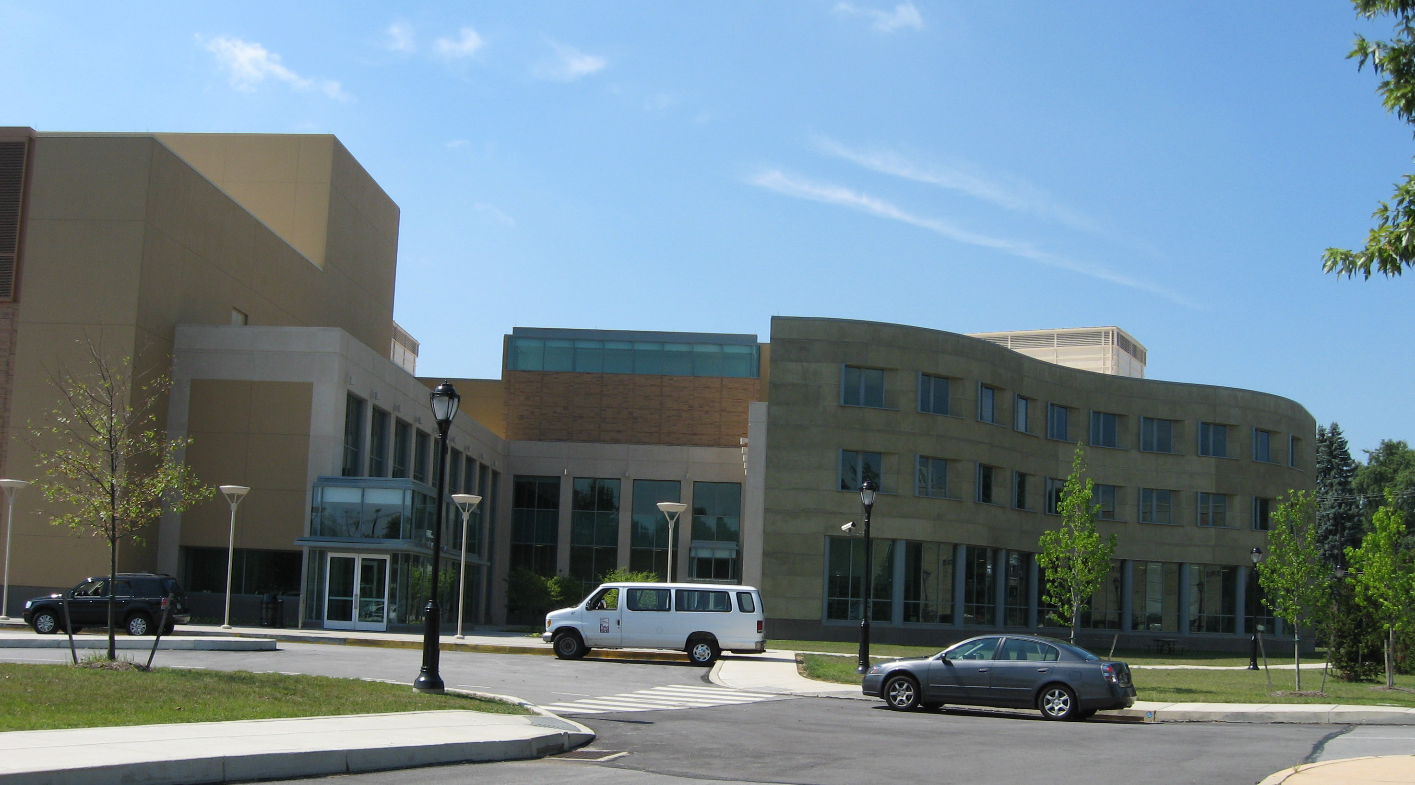

The construction phase of this 90,000 square foot complex commenced in early Summer 2004 and was completed on schedule for occupancy by the School of Music in January 2007. A formal dedication followed in April 2007.

The facility is located directly south of the E.O. Bull Center, at the west end of M lot. Essential features of the design include a curving façade, an interior courtyard, an academic wing, an art gallery, an auditorium and rehearsal hall, “service” activities grouped behind the stage house close to the loading dock, an auditorium for 375 patrons, and a stage-house which will support a range of functions.

The Presser Music Library contains the University’s collection of scores, sound recordings, music books, periodicals and microforms.

Present Use: School of Music Faculty offices, classrooms and Performing Arts Center

Disability Access: Full

Past Projects:

Scheduled Projects or Capital Renovations: None

Description of Construction: Concrete foundations on piers, steel and masonry structure, concrete floors with metal deck, glass curtain wall, brick and stucco finish.

Condition and Use Assessment:
Deferred Maintenance (2007): $ | Est Replacement Cost (2007): $ 23,792 000
Facility Condition Index: 0. | Deficiency/SF: $
Yearly Electric Use Cost: $ | Yearly Water Use Cost $

