
South Campus Deli

839 W. Campus Drive
Built: | Size: 2,143 sf
Acquired: | Condition: Good
Last Renovation: 1993 | Function: AUX

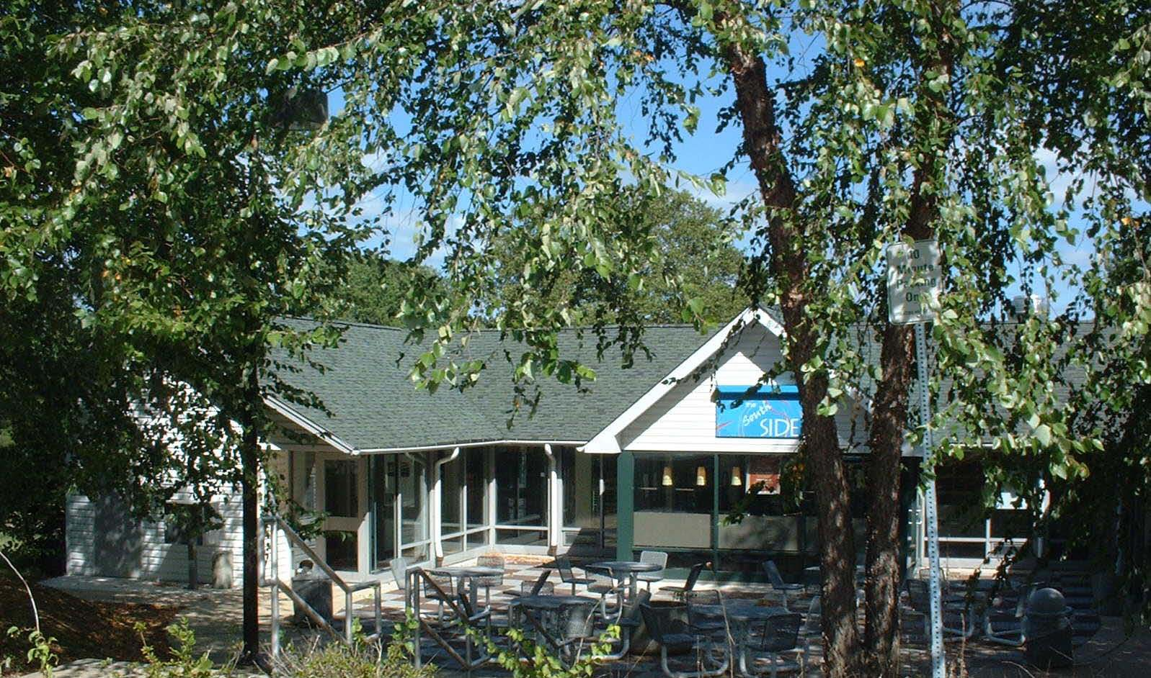

This is the support/convenience facility for the South Campus apartment complex. An underutilized stable was converted to the current use as part of the student housing construction project, utilizing auxiliary-funded bond financing.

Present Use: South Campus deli, mailroom, information center, security office, computer lab, residence director office, graduate assistant office.

Disability Access: Full

Past Projects: Renovation for use as food establishment, 2006 Chick-Fil-A renovations

Scheduled Projects or Capital Renovations: None

Description of Construction: Concrete foundation, wood shingle roof, wood siding on wood frame, concrete and wood floors.

Condition and Use Assessment:
Deferred Maintenance (2007): $ 0 | Est Replacement Cost (2007): $ 381,000
Facility Condition Index: 0. | Deficiency/SF: $ 0
Yearly Electric Use Cost: $ | Yearly Water Use Cost $

