
SC Residence Hall – 840
(formerly #171)

840 S. Campus Drive
Built: 1993 | Size: 10,392 sf
Acquired: N/A | Condition: Good
Last Renovation: | Function: AUX

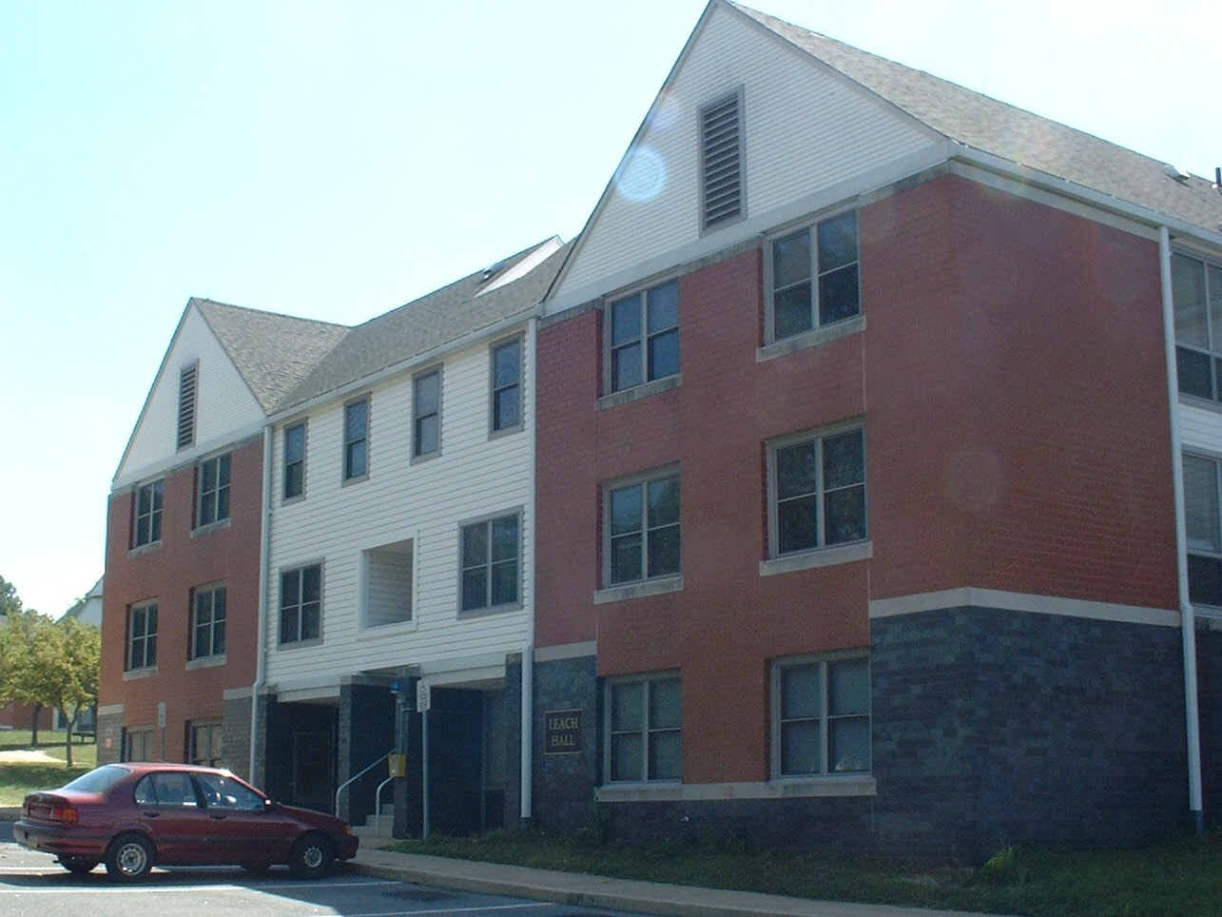

The eleven South Campus garden apartment buildings provide accommodations for 495 students. Each apartment accommodates 4-5 students in 2 or 3 bedrooms, kitchen, bathroom and living area. Each unit is air-conditioned.
Building #840 has ten apartments.

Each building has been updated for sprinkler and fire alarm protection.

Present Use: Student housing, garden apartments

Disability Access: Ground floor apartments only

Past Projects: Sprinkler and fire alarm protection (2003-2005), paint /recarpeting (2006-2007)

Scheduled Projects or Capital Renovations: .Reroofing

Description of Construction: Masonry and vinyl siding, masonry and concrete foundation, vinyl composition roof, concrete floor slabs.

Condition and Use Assessment:
Deferred Maintenance (2006): $ | Est Replacement Cost (2006): $ 2,106,000
Facility Condition Index: 0. | Deficiency/SF: $
Yearly Electric Use Cost: $ | Yearly Water Use Cost $

