
Ruby Jones Hall

50 University Avenue
Built: 1899 | Size: 22,951 sf
Acquired: | Condition: Good
Last Renovation: 1988 | Function: E&G

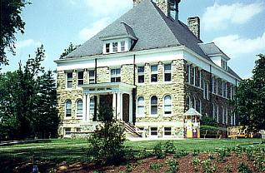

Ruby Jones Hall, built in 1899 by Baker and Dallet Architects, sits on the northwest corner of the Quad along South Church Street and University Avenue. In 1978, after the serpentine structure underwent extensive renovations, it was named in honor of Ruby Johnson Jones, a 1940 graduate of West Chester University, who returned to her alma mater in 1961 to teach until her retirement in 1972. Ruby Jones Hall is included in the Quadrangle Historical District. It has been entered in the National Register of Historical Places.

Once an elementary school, the building now houses administrative offices for the School of Business and Public Affairs and classrooms and offices for the Department of Geography and Planning and the Department of Criminal Justice.

Present Use: Academic classrooms, faculty, and staff offices.

Disability Access: Full, thru elevator lobby at south side

Past Projects: 1978 Serpentine, 1988 Renovation, 1999 corridor carpet, 2002- limited façade repair, 2005 damp-proofing of southern foundation.

Scheduled Projects or Capital Renovations: HVAC modifications- 2008

Description of Construction: Concrete and masonry brick foundation, masonry serpentine stone veneer exterior walls, slate shingle roof, wood floor.

Condition and Use Assessment:
Deferred Maintenance (2007): $ 2,214,000 | Est Replacement Cost (2007): $ 5,329,000
Facility Condition Index: 0.41 | Deficiency/SF: $ 96.47
Yearly Electric Use Cost: $ | Yearly Water Use Cost $

