
Recitation Hall

35 W. Rosedale Avenue
Built: 1892 | Size: 52,357 sf
Acquired: N/A | Condition: Good
Last Renovation: 1989 | Function: E&G

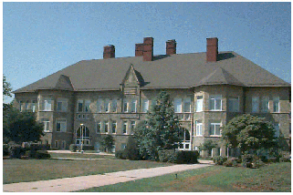

One of the original buildings for the West Chester State Normal School, Recitation Hall now houses the School of Education and general purpose classrooms. Marking the western edge of the Quad, its serpentine rubble stone and slate roof make it one of the architectural treasures on campus.

This building is included in the Quad area National Register of Historic Places.

Present Use: Academic classrooms, faculty and staff offices, computer laboratories.

Disability Access: Full, thru elevator lobby at rear of building facing Anderson.

Past Projects: 1989 General, 1997 Roof, 1998 Dean’s Office, 2000 Space Technology, 2004 Corridor carpeting.

Scheduled Projects or Capital Renovations: 2008- Façade restoration

Description of Construction: Concrete and masonry brick foundation, asphalt shingle roof, masonry serpentine stone veneer exterior walls, wood floor.

Condition and Use Assessment:
Deferred Maintenance (2007): $ 4,715,000 | Est Replacement Cost (2007): $ 12,643,000
Facility Condition Index: 0.372 | Deficiency/SF: $ 90.05
Yearly Electric Use Cost: $ | Yearly Water Use Cost $

