
809 Roslyn Avenue

Built: 1950 | Size: 2,373 sf
Acquired: 1964 | Condition: Fair
Last Renovation: 1998 | Function: E&G

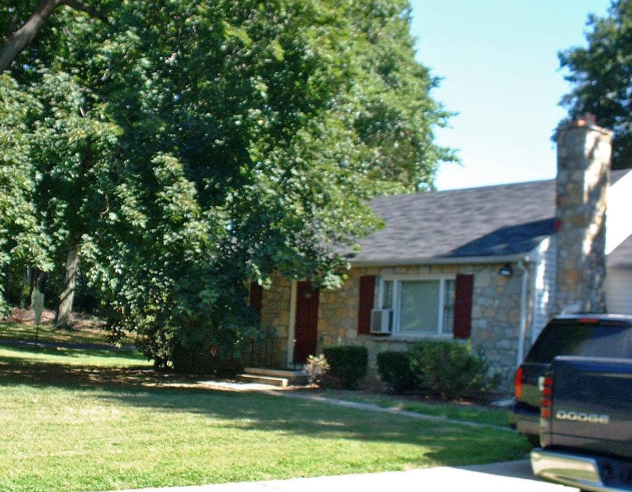

The Office of Research and Planning is located in 809 Roslyn Avenue, which is just southwest of the Sykes Student Union building. This building was formerly a private residence and is surrounded by a large yard adjacent to the expansive parking lot behind Sykes.

Present Use: Offices

Disability Access: Full, with ramp at rear and accessible parking at K Lot.

Past Projects: 1998 Roof

Scheduled Projects or Capital Renovations: None

Description of Construction: Masonry block foundation, asphalt shingle roof, wood siding on wood frame exterior walls, wood floors.

Condition and Use Assessment:
Deferred Maintenance (2007): $ 0 | Est Replacement Cost (2007): $ 509,000
Facility Condition Index: 0. | Deficiency/SF: $ 0
Yearly Electric Use Cost: $ | Yearly Water Use Cost $

