
Philips Memorial Building

700 S. High Street
Built: 1925 | Size: 51,502 sf
Acquired: N/A | Condition: Excellent
Last Renovation: 1999 | Function: E&G
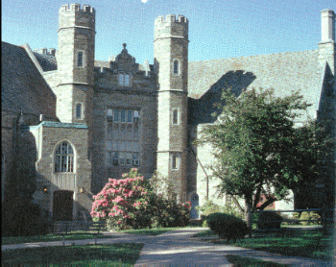
Philips Memorial Hall is not only the architectural gem of the campus, but of West Chester Borough as well. The building, named after George M. Philips (Principal from 1881-1920), was originally opened in 1927 and is now on the National Register for Historic Places. Designed by Walter F. Price, the exterior is fashioned from hammer-dressed Foxcroft Wissahickon Schist, a local stone commonly used for buildings in the Collegiate Gothic style. Thanks to the generous support of Emily Kessel Asplundh '27 and
many generous alumni and friends, extensive preservation and renovations were completed in 1999. Special features include: the whispering archway; the distinctive gargoyles; coats of arms and figures of western civilization; the 2000-volume Philips Autographed Library; the 1200-seat Emily K. Asplundh Concert Hall; and the
Presidential office suite.
Present Use: Administrative offices and auditorium

Disability Access: Full, with side elevator lobby near main entrance doors.

Past Projects: 1999 Renovation, 2000 Roof, 2007 HVAC Controls

Scheduled Projects or Capital Renovations: An extensive life-cycle renovation of Philips Memorial Building was completed in 1999. The project totaled $14,500,000, of which $4,900,000 was capital budget funding, and the remainder coming from donors and University sources. Extensive exterior stone work, replacement of all mechanical and electrical systems, complete ADA accessibility, and restoration of interior surfaces and furnishings were accomplished.

Description of Construction: Reinforced concrete foundation, slate shingle roof, masonry stone veneer exterior walls, concrete slab floors.

Condition and Use Assessment:
Deferred Maintenance (2007): $ 12,000 | Est Replacement Cost (2007): $ 14,312,000
Facility Condition Index: 0.00 | Deficiency/SF: $ 0.22
Yearly Electric Use Cost: $ | Yearly Water Use Cost $

