
Peoples Building

690 S. Church Street
Built: 1969 | Size: 17,895 sf
Acquired: N/A | Condition: Good
Last Renovation: 1996 | Function: E&G

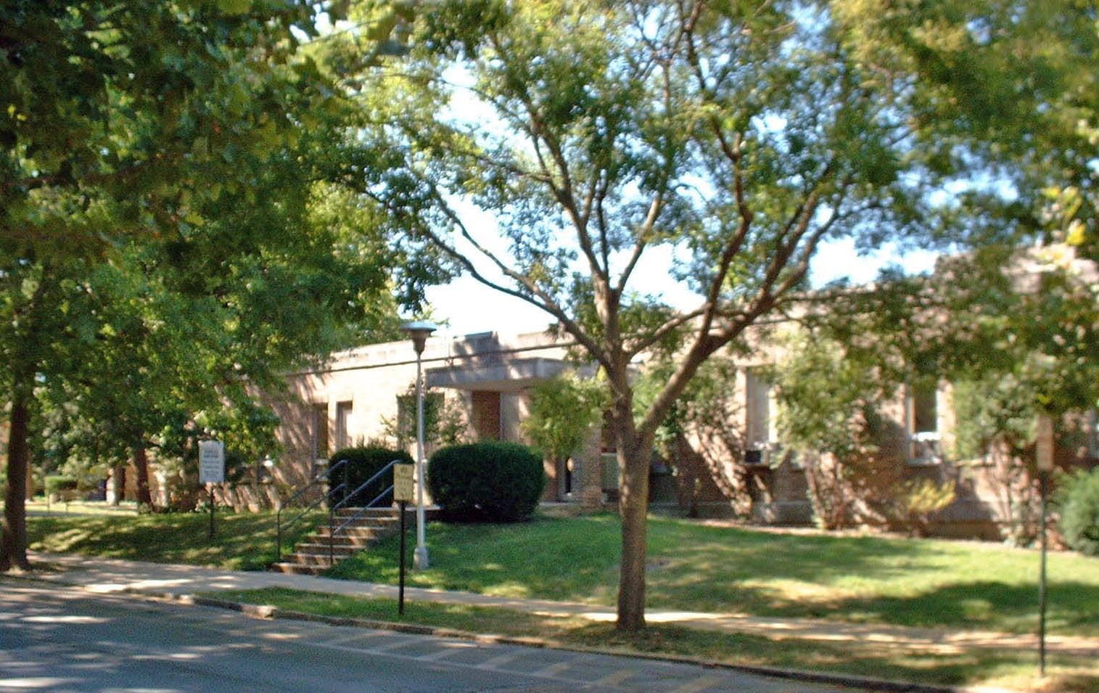

The Peoples Building sits across the street from Ehinger Gymnasium on the corner of University Avenue and South Church Street. In addition to being the home of the Public Safety Department, it also houses the Psychology Department. Extensive renovations were accomplished in the Psychology Department offices and labs during the late 1990s. A major telecommunications hub is housed in the basement area.

Present Use: Public Safety offices, Psychology Department laboratories, research space and offices, and telecommunications switching.

Disability Access: Full, thru ramp at side entrance.

Past Projects: 1996 Partial Renovation, 1995 Addition Roof, 1998 Roof and Public Safety Dispatch Rm.

Scheduled Projects or Capital Renovations: None

Description of Construction: Reinforced concrete foundation, built-up roof, masonry brick veneer exterior walls, concrete slab floors.

Condition and Use Assessment:
Deferred Maintenance (2007): $ 30,000 | Est Replacement Cost (2007): $ 4,406,000
Facility Condition Index: 0.01 | Deficiency/SF: $1.68
Yearly Electric Use Cost: $ | Yearly Water Use Cost $

