
Main Hall

720 S. High Street
Built: 1974 | Size: 73,204 sf
Acquired: N/A | Condition: Fair
Last Renovation: | Function: E&G

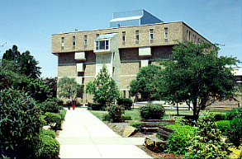

Main Hall forms the eastern boundary of the Quad along High Street. The building houses twenty-three classrooms, a large lecture hall, the office of the Dean of the College of Arts and Sciences, and office space for faculty and staff of numerous departments in the College of Arts and Sciences, including English, Foreign Languages, and History.

Present Use: Classrooms, offices, and lecture hall

Disability Access: Full, with two elevators, and accessible bathrooms on various floors.

Past Projects: 1999- Chiller replacement, Dean’s Suite, Emergency structural repairs at shelf angle supporting the fifth floor overhang, 2005- New classroom air conditioning units 2004-2005 Short term structural repairs. Auditorium upgrades are planned for 2008. A re-roofing project is planned for 2009, after a Cooling Tower replacement in 2008.

Scheduled Projects or Capital Renovations: None

Description of Construction: Reinforced concrete foundation, built-up roof, masonry brick veneer exterior wall, concrete slab floors.

Condition and Use Assessment:
Deferred Maintenance (2007): $ 800,000 | Est Replacement Cost (2007): $ 18,089,000
Facility Condition Index: 0.04 | Deficiency/SF: $ 10.92
Yearly Electric Use Cost: $ | Yearly Water Use Cost $

