
Mitchell Hall

675 S. Church Street
Built: 1970 | Size: 38,293 sf
Acquired: N/A | Condition: Fair
Last Renovation: | Function: E&G

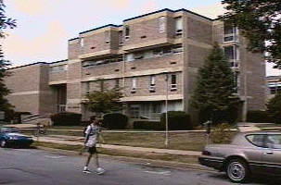

Mitchell Hall is a four-story building prominently located on Church Street. The Art Department utilizes this building, prior to their eventual relocation to a future renovated EO Bull Center. Mitchell Hall houses art galleries on the main floor, as well as art and compute studios; classrooms; and faculty office space occupy the other floors.

The future users of this building, once the Art Department relocates to a renovated EO Bull Center, have not yet been identified.

Present Use: Art classrooms, laboratories and exhibit rooms, and faculty offices. Autism Clinic and Statistics and Geology Institutes located on the 4th floor.

Disability Access: Full, thru ramp at rear of bldg.

Past Projects: 1992 Chilled/hot water piping, 1994 Art Gallery, 1996 CFC chiller & two art exhibit rooms refurbished, 1997 Roof, 2000 Fire alarm, 2001 Clay Lab and Photo Lab

Scheduled Projects or Capital Renovations: $7.8 million in Capital Monies have been scheduled for release for a life-cycle renovation of this building after the Art Department relocates to EO Bull Center.

Description of Construction: Reinforced concrete foundation, built-up roof, masonry brick veneer exterior walls, concrete slab floors.

Condition and Use Assessment:
Deferred Maintenance (2007): $ 1,376,000 | Est Replacement Cost (2007): $ 11,928,000
Facility Condition Index: 0.12 | Deficiency/SF: $ 35.93
Yearly Electric Use Cost: $ | Yearly Water Use Cost $

