
Messikomer Hall

100 W. Rosedale Avenue
Built: | Size: 7,909 sf
Acquired: 1989 | Condition: Good
Last Renovation: 1989 (incl roof- center section), 1999 (west porch) | Function: E&G

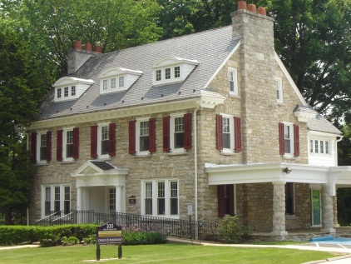

Named after Emil H. Messikomer, this attractive facility is utilized as an Admissions Center and provides a lasting impression on visitors to the campus. Once a private residence, the building boasts many interior architectural elements that create a comfortable atmosphere, including stone fireplaces, a winding central staircase, and hardwood floors. Accessible and visitor parking is located in an adjacent lot.

Present Use: Admissions Office

Disability Access: 1st floor only via front ramp, includes accessible restroom.

Past Projects: 1988- General renovation and roof (Center section), 1999 West porch

Scheduled Projects or Capital Renovations: None

Description of Construction: Concrete and stone foundation, stone facade, slate sloped roof.

Condition and Use Assessment:
Deferred Maintenance (2007): $ 0 | Est Replacement Cost (2007): $ 1,644,000
Facility Condition Index: 0. | Deficiency/SF: $
Yearly Electric Use Cost: $ | Yearly Water Use Cost $

