
McKelvie Hall

102 W. Rosedale Avenue
Built: 1904 | Size: 4,774 sf
Acquired: 1995 | Condition: Good
Last Renovation: 1995 | Function: E&G

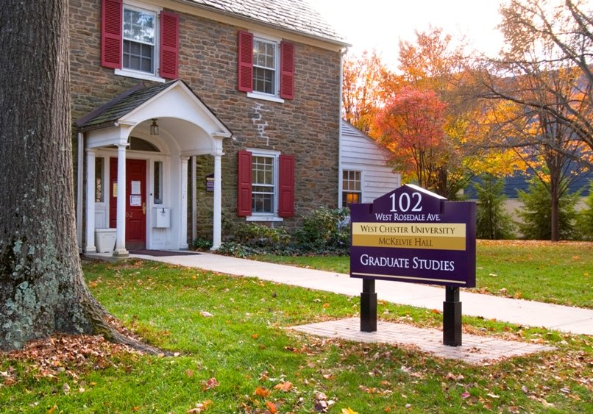

Named after Clarence McKelvie, this attractive former residence is used by the Offices of Graduate Studies and Extended Education (GSEE) and the International Programs Department. Accessible and reserved parking is found in an adjacent lot.

Present Use: Offices of Graduate Studies

Disability Access: 1st floor only, with meeting room.

Past Projects: 1995 Renovation, 1998 Roof, 2006 Exterior Painting

Scheduled Projects or Capital Renovations: None

Description of Construction: Concrete foundations, slate roof, combination stone and aluminum siding, wood and concrete floor.

Condition and Use Assessment:
Deferred Maintenance (2007): $ 0 | Est Replacement Cost (2007): $ 1,025,000
Facility Condition Index: 0. | Deficiency/SF: $ 0
Yearly Electric Use Cost: $ | Yearly Water Use Cost $

