
McCoy Garrison

804 South Campus Drive
Built: 1972 | Size: 1,118 sf
Acquired: | Condition: Poor
Last Renovation: 1992 | Function: E&G

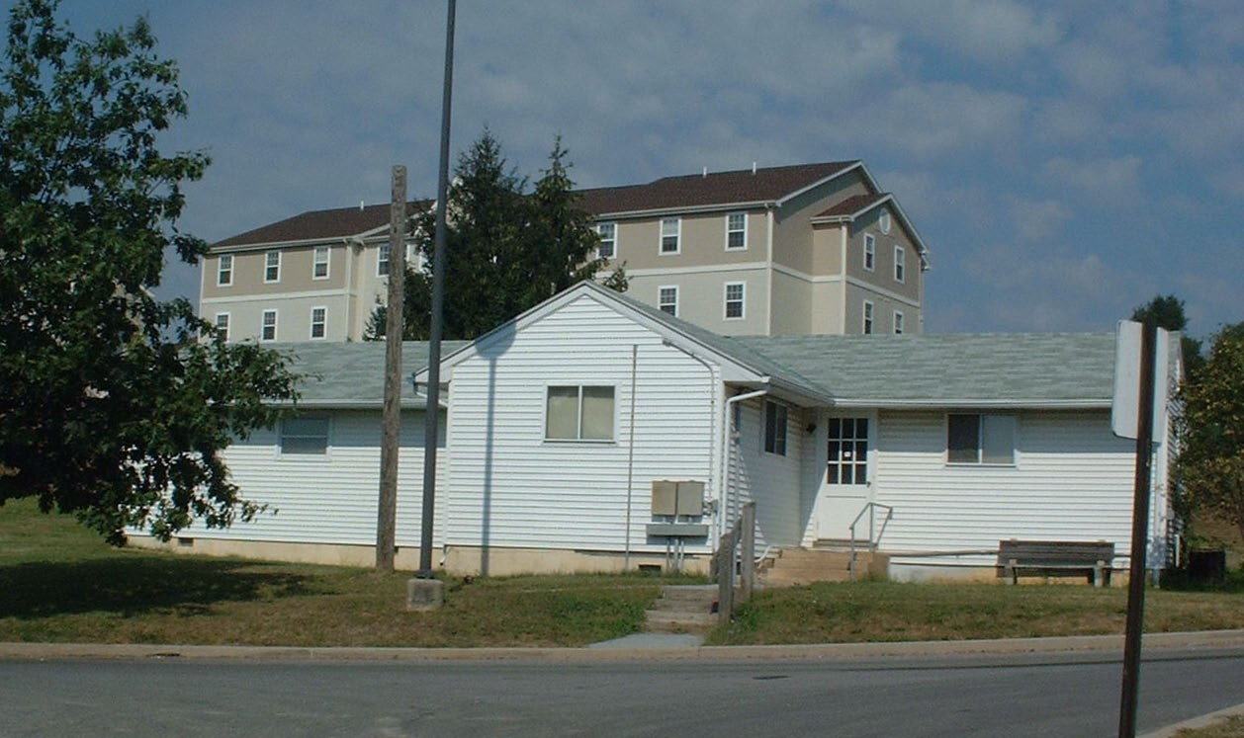

This structure was once utilized as construction offices for the South Campus Apartments, as a Grounds Department offices and break room; it is currently used as a Break Room for Public Safety Officers patrolling South Campus Apartments.

Present Use: Public Safety Officer Break Area

Disability Access: None

Past Projects:

Scheduled Projects or Capital Renovations: None

Description of Construction: Concrete and masonry block foundation, asphalt shingle roof, wood siding on wood frame exterior walls, wood floors.

Condition and Use Assessment:
Deferred Maintenance (2007): $ 0 | Est Replacement Cost (2007): $ 213,000
Facility Condition Index: 0. | Deficiency/SF: $
Yearly Electric Use Cost: $ | Yearly Water Use Cost $

