
McCoy Farmhouse

801 South Campus Drive
Built: 1920s | Size: 9,013 sf
Acquired: 1958 | Condition: Fair
Last Renovation: 1997 | Function: E&G

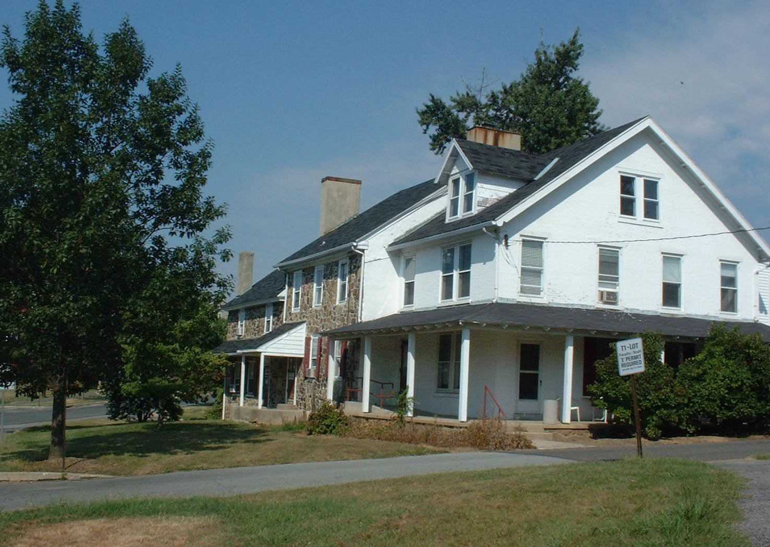
The McCoy farmhouse is an attractive facility that marks the entrance to the South Campus Aparmtet . However, its separation from North Campus, as well as the Health Sciences Center on South Campus, is a drawback for any academic occupants. The Grounds Department has occupied both floors of this building since 2002.

Present Use: Grounds Department offices, locker rooms, break rooms.

Disability Access: 1st floor only thru entrance near accessible parking

Past Projects: 1989 Roof, 1997 General Renovations for Social Work Faculty, 2003 electrical-telephone upgrade.

Scheduled Projects or Capital Renovations: Rear porch repair, storm windows.

Description of Construction: Concrete and stone masonry foundations, asphalt shingle metal roof, combination masonry brick/stone/wood frame and siding exterior walls, wood and concrete floors.

Condition and Use Assessment:
Deferred Maintenance (2007): $ 144,000 | Est Replacement Cost (2007): $ 1,935,000
Facility Condition Index: 0.07 | Deficiency/SF: $ 15.97
Yearly Electric Use Cost: $ | Yearly Water Use Cost $

