
McCoy Equipment Barn

800 S. New Street
Built: 1989 | Size: 2,400 sf
Acquired: | Condition: Good
Last Renovation: | Function: E&G

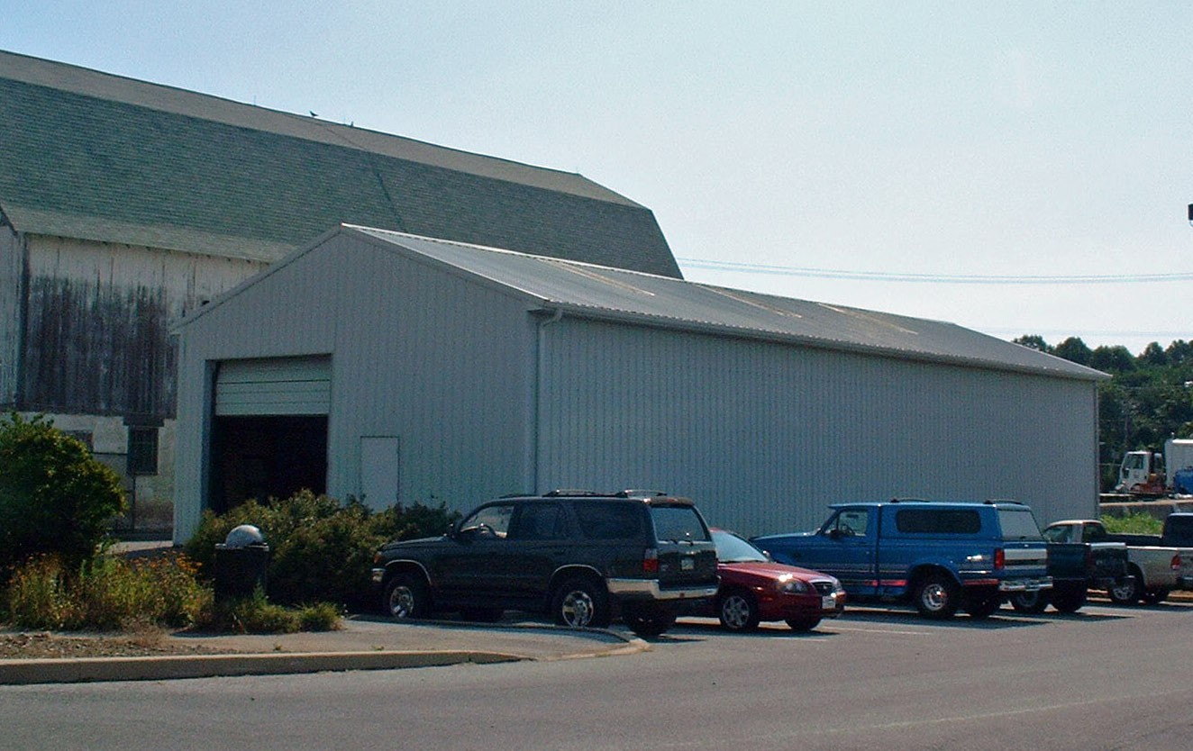

Present Use: Grounds Department Equipment storage

Disability Access: Full (at grade)

Past Projects:

Scheduled Projects or Capital Renovations: None

Description of Construction: Wood frame pole barn with metal siding and roof and concrete slab.

Condition and Use Assessment:
Deferred Maintenance (2007): $ 0 | Est Replacement Cost (2007): $ 379,000
Facility Condition Index: 0. | Deficiency/SF: $
Yearly Electric Use Cost: $ | Yearly Water Use Cost $

