
McCoy Barn

802 South Campus Drive
Built: 1800s | Size: 9,645 sf
Acquired: 1958 | Condition: Poor
Last Renovation: | Function: E&G

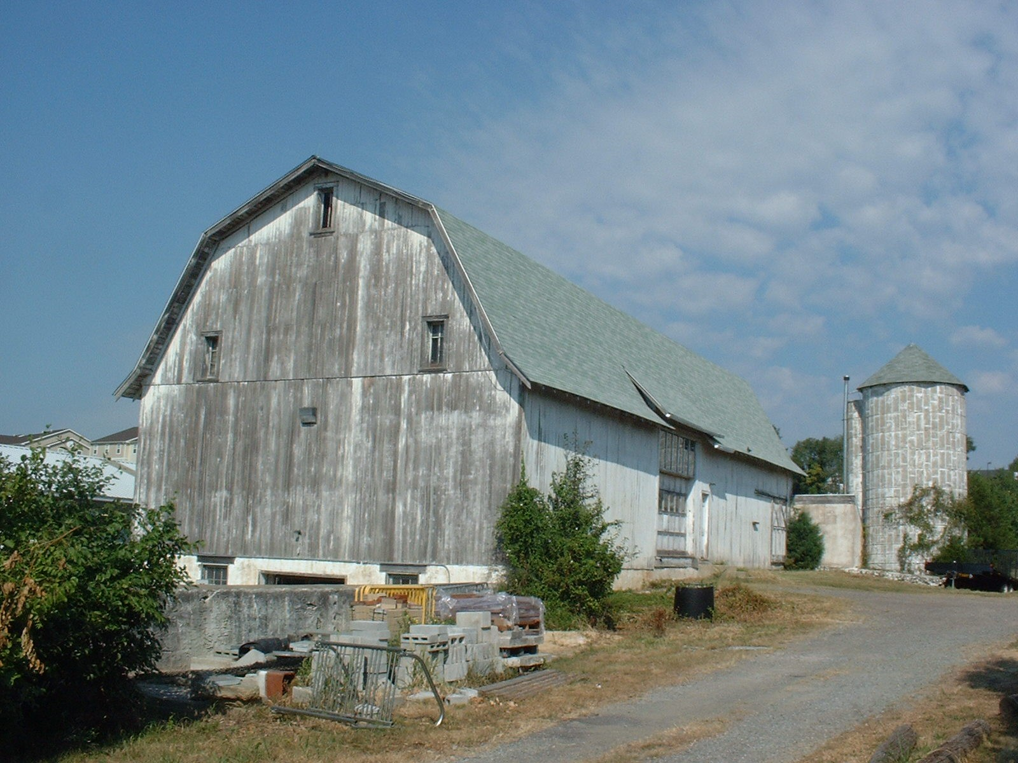

Present Use: Grounds Equipment, lumber and miscellaneous storage

Disability Access: Ground level only

Past Projects: 1992 Roof – Partial, 2007- Paint and siding.

Scheduled Projects or Capital Renovations: None

Description of Construction: Stone masonry foundation, asphalt shingle roof, wood frame, wood exterior walls, and concrete floors.

Condition and Use Assessment:
Deferred Maintenance (2007): $ N/A | Est Replacement Cost (2007): $ 1,524,000
Facility Condition Index: 0. | Deficiency/SF: $
Yearly Electric Use Cost: $ | Yearly Water Use Cost $

