
210 E. Rosedale Avenue

Built: | Size: 4,200 sf
Acquired: 1995 | Condition: Excellent
Last Renovation: 1998 | Function: E&G

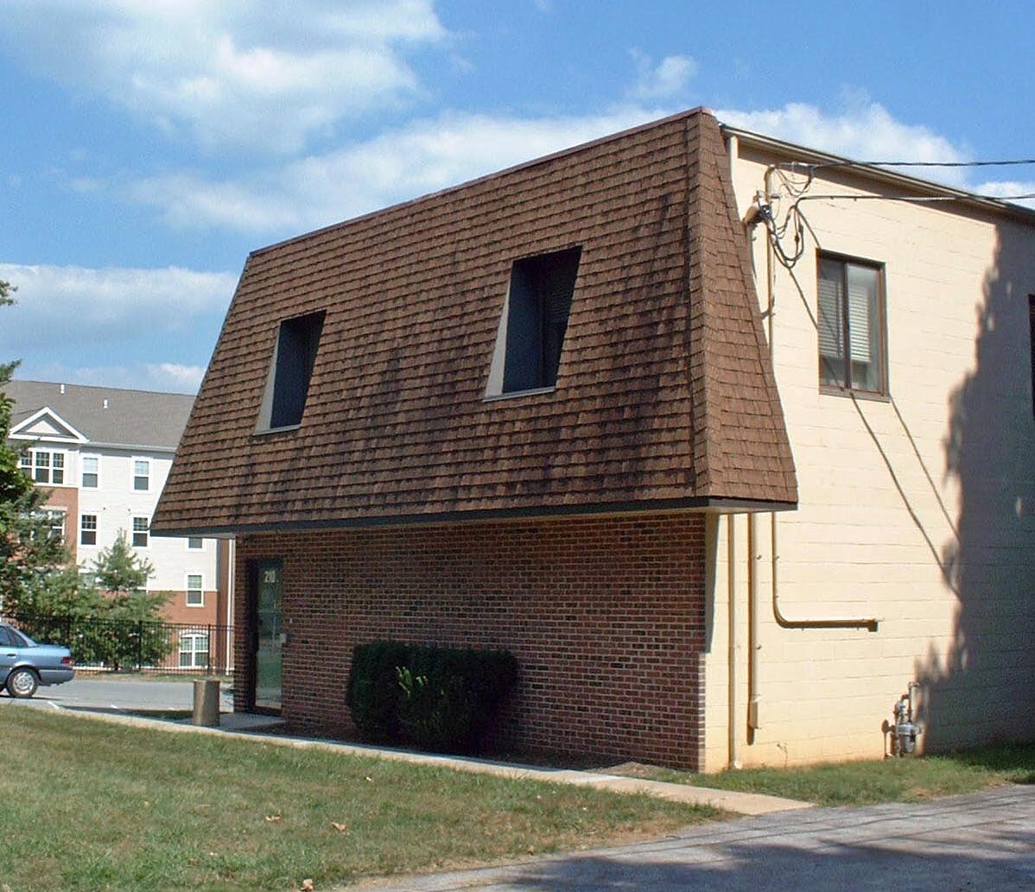

The interior has been renovated to accommodate the Pennsylvania Writing Project and College Literature.

Present Use: Administrative office and training space

Disability Access: 1st floor only, no elevator to second floor.

Past Projects: General fit out for use- 1995

Scheduled Projects or Capital Renovations:

Description of Construction: Concrete and masonry foundation, brick and cinder block exterior, shingle roof

Condition and Use Assessment:
Deferred Maintenance (2007): $ 25,000 | Est Replacement Cost (2006): $ 940,000
Facility Condition Index: 0.026 | Deficiency/SF: $ 5.95
Yearly Electric Use Cost: $ | Yearly Water Use Cost $

