
FH Green Library – Phase I

25 W. Rosedale Avenue
Built: 1966 | Size: 60,082 sf
Acquired: N/A | Condition: Fair
Last Renovation: | Function: E&G

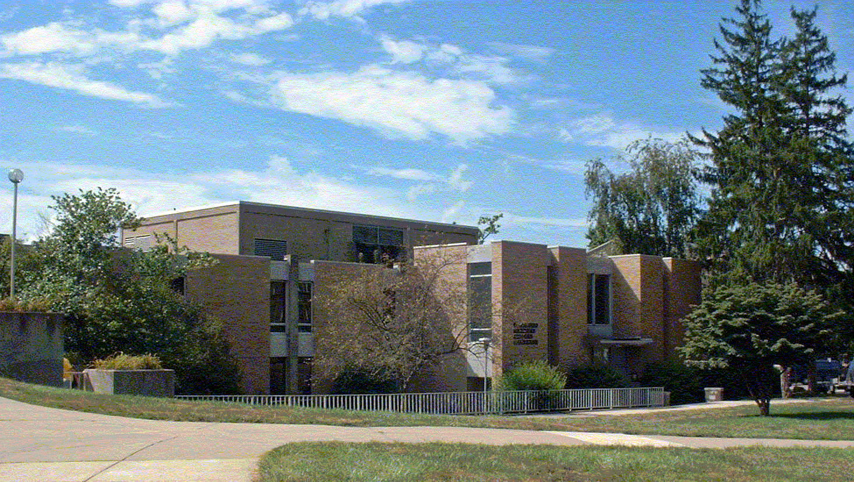

The six-story Francis Harvey Green Library (Phases I & II) sits prominently upon the knoll on the northwest corner of West Rosedale Avenue and South High Street. It was constructed in two phases, a two story structure in 1966, and a six story addition in 1976. Essentially, the building operates as two separate structures, with separate mechanical systems and life-cycle repairs. The entrance of the library faces the Quad, putting its back to the street. The library is furnished with a variety of seating areas, including individual study carrels, faculty and graduate lounges, group study areas, seminar rooms, and general reading areas. Its total resources number more than 874,000 volumes. A number of historical collections are housed in the Special Collections Room on the sixth floor.

Present Use: Library facility

Disability Access: Full, with elevator and accessible restrooms on 2nd and 6th floors.

Past Projects: 1997 Roof, 2007 Starbucks Café, 2008 HVAC and Fire Alarm Modifications

Scheduled Projects or Capital Renovations: A Capital Project totaling $18.5 million has been authorized by the Legislature in 2000, but this project amount has quickly been outdated, and other campus priorities remain.

Description of Construction: Reinforced concrete foundation, built-up roof, masonry brick veneer exterior walls, concrete slab floors.

Condition and Use Assessment:
Deferred Maintenance (2007): $ 900,000 | Est Replacement Cost (2007): $ 13,478,000
Facility Condition Index: 0.07 | Deficiency/SF: $ 14.98
Yearly Electric Use Cost: $ | Yearly Water Use Cost $

