
Lawrence Hall

705 S. New Street
Built: 1965 | Size: 94,191 sf
Acquired: N/A | Condition: Fair
Last Renovation: | Function: E&G

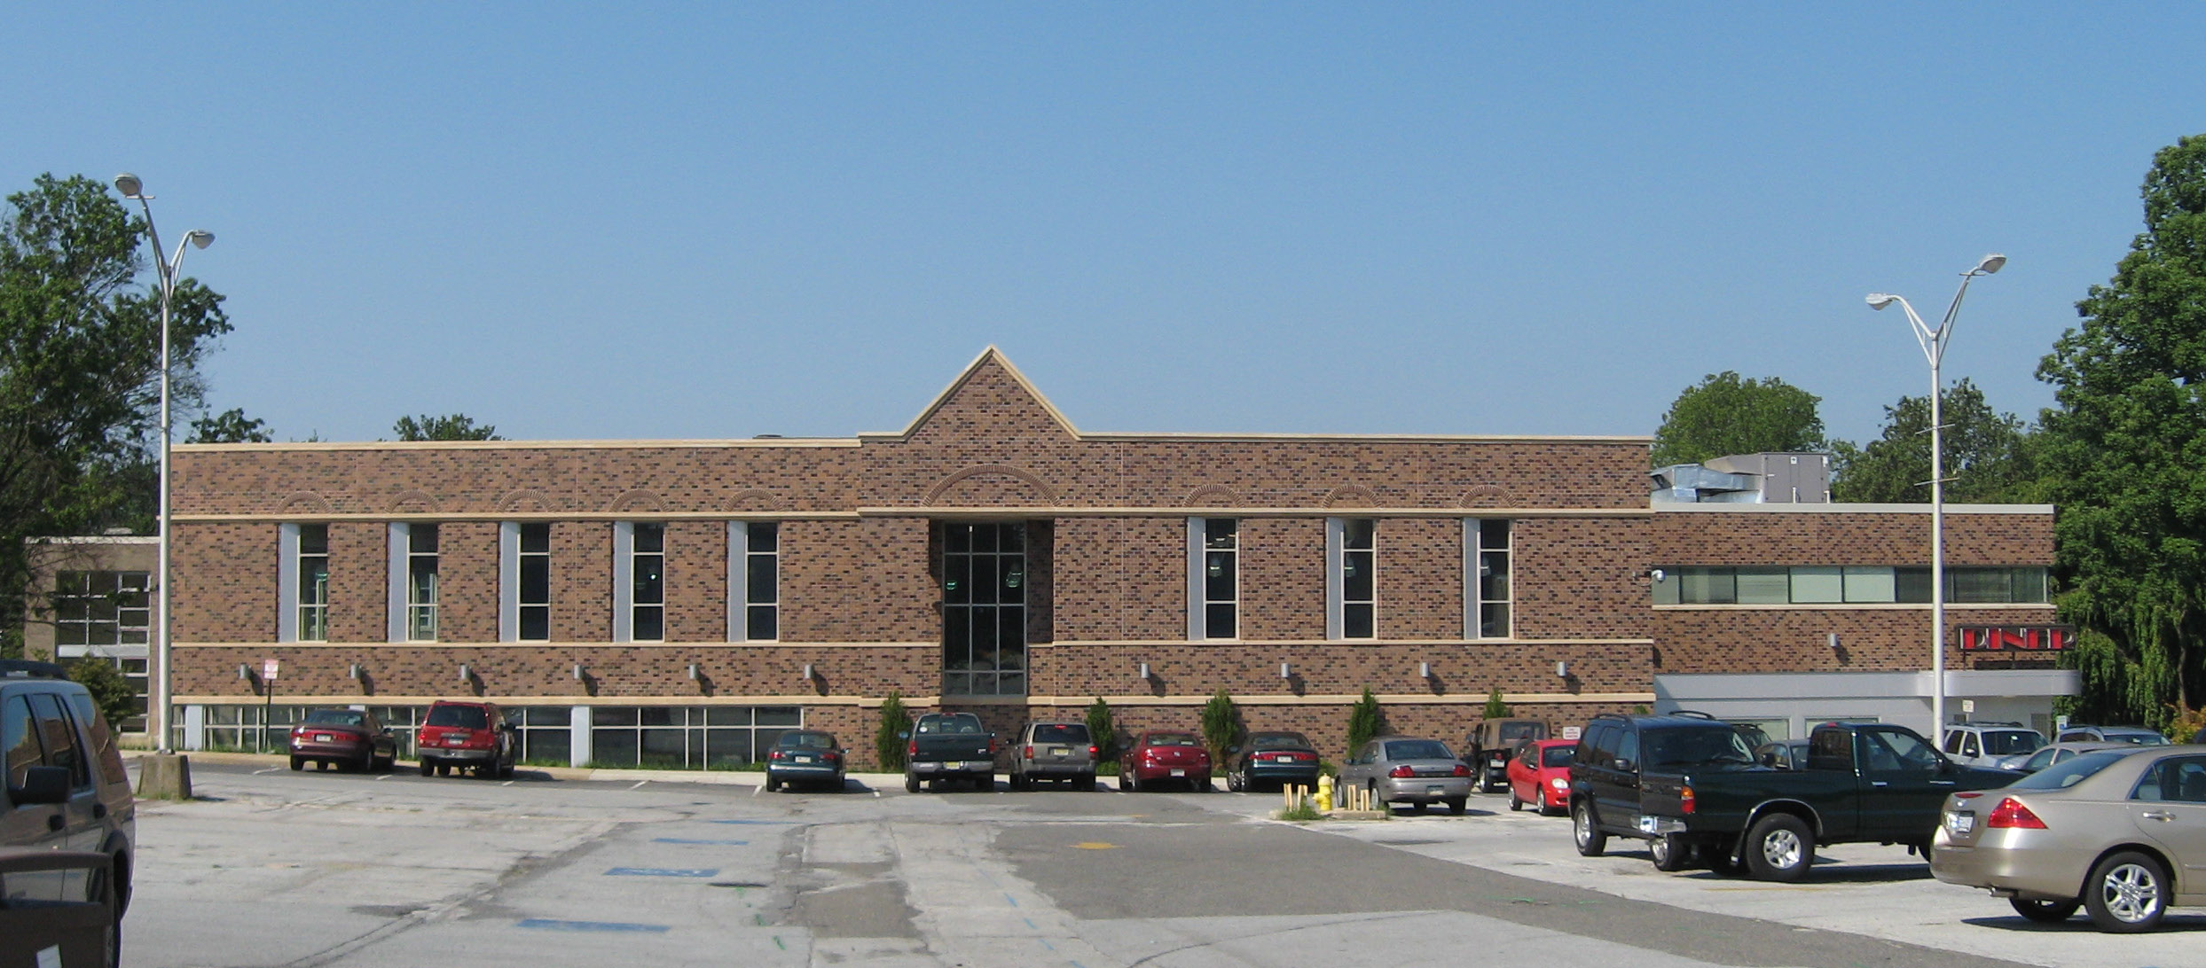

Lawrence Hall, conveniently located between two residence halls, is a two-story building backing up to South New Street with the main entrance currently facing Parking Lot D. It houses the University Dining Hall on the ground floor and numerous student services on the second floor: Counseling/Academic Advising, Tutoring Center, Career Development Center, Women's Center, and the Post Office. A 5000 SF addition housing Student Affairs offices, a circa 1950s late-night Diner, and two retail food operations was constructed in the current courtyard and occupied in 2006.

Present Use: Dining hall, post office facilities, Academic Counseling, Career Development offices, Offices of Student Services with Disabilities, Women’s Center, office space.

Disability Access: Full, with elevator and accessible parking.

Past Projects: 1997 Roof, 1998 Main Dining Area renovation, 2000 Traditions Dining area, 2006 Dining Addition, 2007 Food Court, 2008 HVAC upgrades.

Scheduled Projects or Capital Renovations: A Capital renovation project for $6.3 million was authorized by the Legislature in 2002 for the second floor of the building, but has not yet been funded.

Description of Construction: Reinforced concrete foundation, built-up roof, masonry brick veneer exterior walls, concrete slab floors.

Condition and Use Assessment:
Deferred Maintenance (2007): $ 476,000 | Est Replacement Cost (2007): $ 32,636,000
Facility Condition Index: 0.014 | Deficiency/SF: $ 4.26
Yearly Electric Use Cost: $ | Yearly Water Use Cost $

