
Killinger Hall

115 W. Rosedale Avenue
Built: 1959 | Size: 69,382 sf
Acquired: N/A | Condition: Fair
Last Renovation: 1989 | Function: AUX

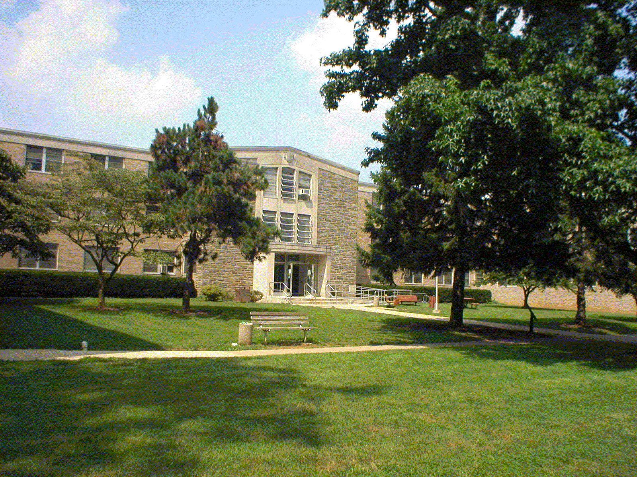

Killinger Hall has been heavily used for 39 years. The interior is in good shape, but the structure and electrical and mechanical systems are in poor condition. The building is in need of complete renovation.

A long-range plan to replace six of the other residence halls with new structures is being developed, while Goshen and Killinger Halls will remain in place. The cost of a complete building renovation is currently estimated at over $6,000,000. Killinger Hall was last refurbished in 1989. LAN/Telephone/CATV and Sprinkler & Fire Alarm upgrades were completed in 2003, while window replacements were completed in 2004.

Present Use: Residence Hall

Disability Access: Full, with new elevator and ramp and several accessible student rooms.

Past Projects: 1989 General, 1991 Roof, 1998 Furniture, 2000 New Elevator, 2001 ADA ramp and restrooms, 2003 LAN/Telephone/CATV and Sprinkler and Fire Alarm upgrades, 2005 New Windows, 2007new carpet.

Scheduled Projects or Capital Renovations: None

Description of Construction: Reinforced concrete foundation and structure; built-up roof; masonry brick veneer exterior walls; concrete slab floors.

Condition and Use Assessment:
Deferred Maintenance (2007): $ 1,443,000 | Est Replacement Cost (2007): $ 14,060,000
Facility Condition Index: 0.10 | Deficiency/SF: $ 20.79
Yearly Electric Use Cost: $ | Yearly Water Use Cost $

