
Russell L. Sturzebecker Health Sciences Center

855 S. New Street
Built: 1970 | Size: 209,315 sf
Acquired: N/A | Condition: Fair
Last Renovation: 2002 | Function: E&G

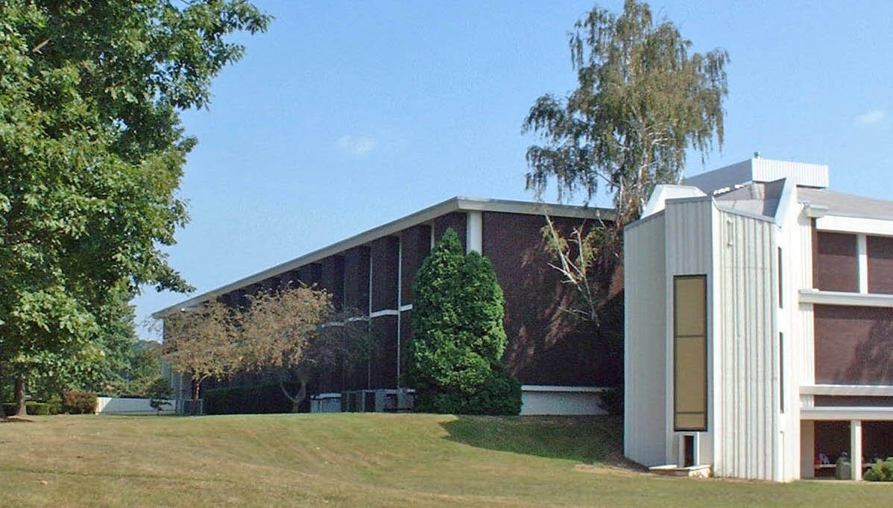

The Sturzebecker Health Sciences Center is located on South Campus between Farrell Stadium and the baseball and tennis courts. This building houses the offices of the Dean of Health Sciences and his staff, and the Health, Kinesiology and Sports Medicine Departments. Other facilities within this building include classrooms, gymnasiums, Fitness rooms, a Dance Studio, a Human Performance lab, a Nutrition Lab, an Environmental Lab, computer rooms for health science students, a student lounge area, swimming pools and a diving well, sports medicine's athletic training rooms equipped with state-of-the-art Cyber equipment, and a recreational outdoor pursuits education (ROPE) course.

Present Use: Gymnasiums, natatorium, classrooms, and faculty and staff offices.

Disability Access: Full, with access thru the northeast stairwell to a nearby elevator. Accessible locker rooms and restrooms.

Past Projects: 1991- Athletics Dept Offices, 1994 Roof and Swimming Pool Renovation, 1995 Fire repairs, 1998 Roof-Mech. Bldg., 2001 Pool pumps- Fire Alarm upgrades, 2002 Classroom renovation (Nursing Dept relocation), 2003 New Corridor Floors 1st & 2nd, 2006-2007 New Stairwell carpeting.

Scheduled Projects or Capital Renovations: A feasibility study for a building addition is being pursued.

Description of Construction: Reinforced concrete foundation, reinforced concrete and precast concrete exterior walls, masonry brick veneer, concrete slab floor, built-up membrane roof.

Condition and Use Assessment:
Deferred Maintenance (2007): $ 1,775,000 | Est Replacement Cost (2007): $ 48,648,000
Facility Condition Index: 0.036 | Deficiency/SF: $ 8.46
Yearly Electric Use Cost: $ | Yearly Water Use Cost $

