
823 S. High Street

823 S. High Street
Built: 1900 | Size: 3,256 sf
Acquired: 2001 | Condition: Very Good
Last Renovation: 2002 | Function: E&G

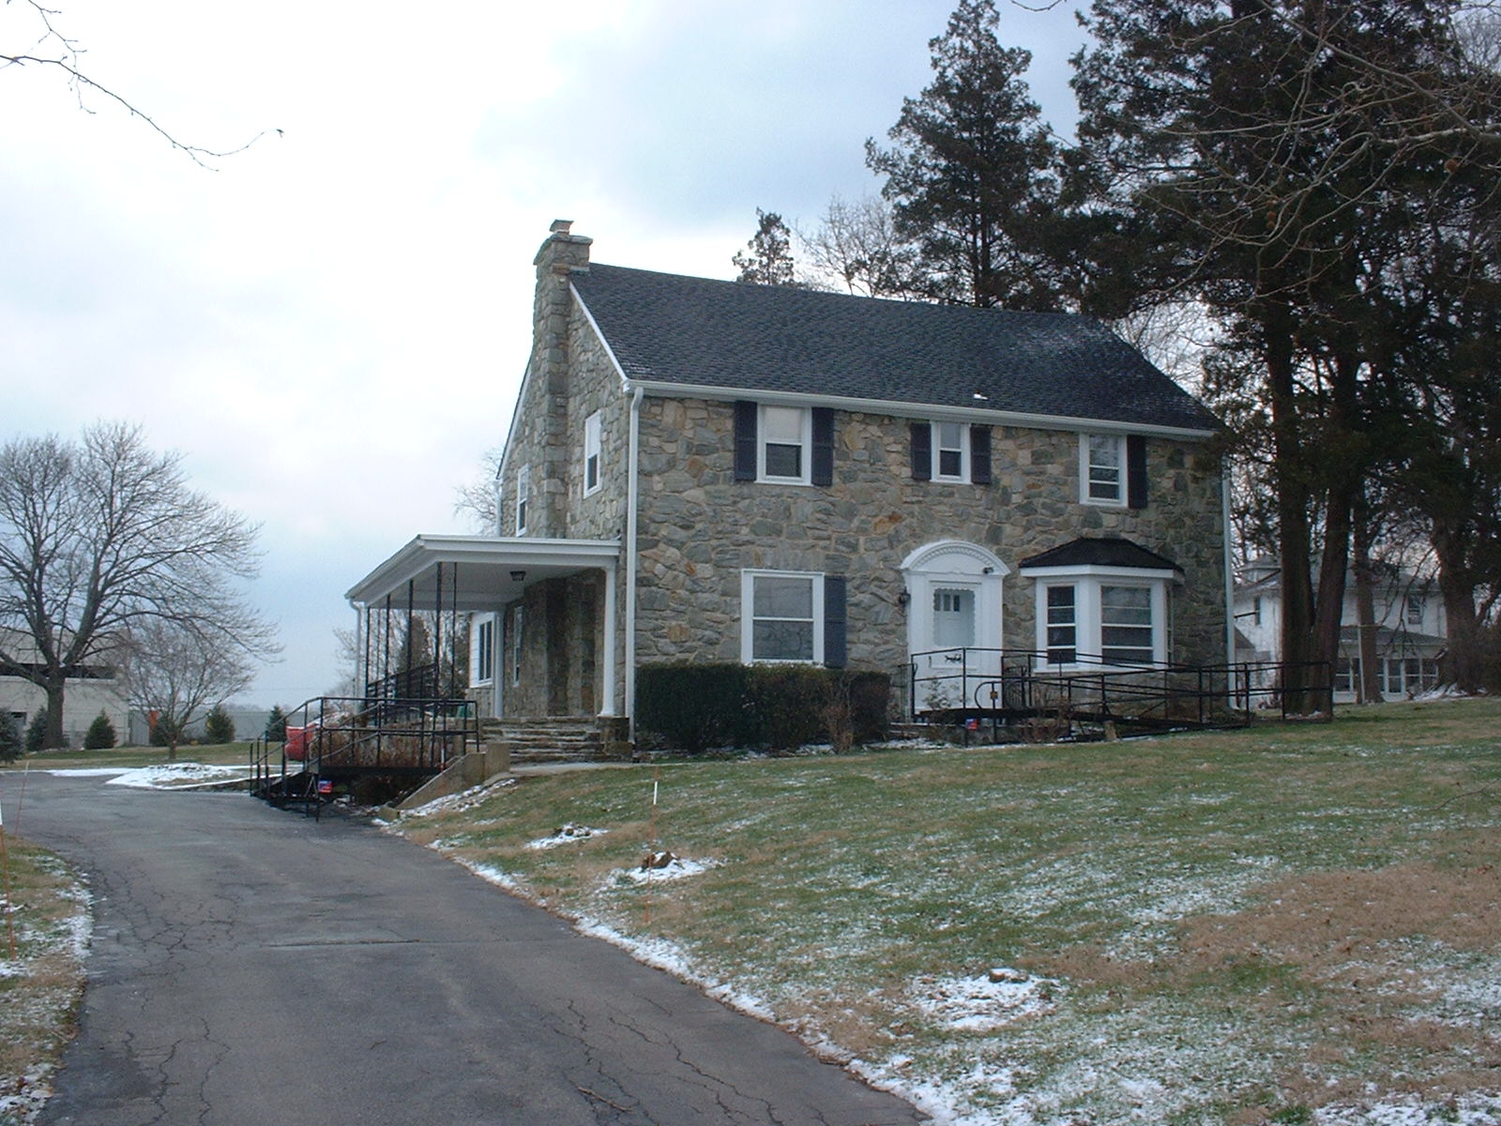
823 S. High Street , is in very good condition. It has been recently renovated to include a 200 amp electric service, new appliances, fire alarms, paint and expose carpet from existing wood floors, and removal of ACM from tile in basement.

The University’s Poetry Center currently occupies this building.

Present Use: Faculty and Staff offices and meeting room.

Disability Access: 1st floor only, including accessible unisex restroom.

Past Projects: General renovation 2006

Scheduled Projects or Capital Renovations: None

Description of Construction: Reinforced masonry foundation, slate roof, stone construction, wood framed windows, veneer exterior walls, concrete slab basement floors and wood construction upper floors.

Condition and Use Assessment:
Deferred Maintenance (2007): $ 0 | Est Replacement Cost (2007): $ 699,000
Facility Condition Index: 0. | Deficiency/SF: $ 0
Yearly Electric Use Cost: $ | Yearly Water Use Cost $

