
Glen Echo Main House

844 S. New Street
Built: Late 1800’s | Size: 4,477 sf
Acquired: 1968 | Condition: Poor
Last Renovation: | Function: E&G

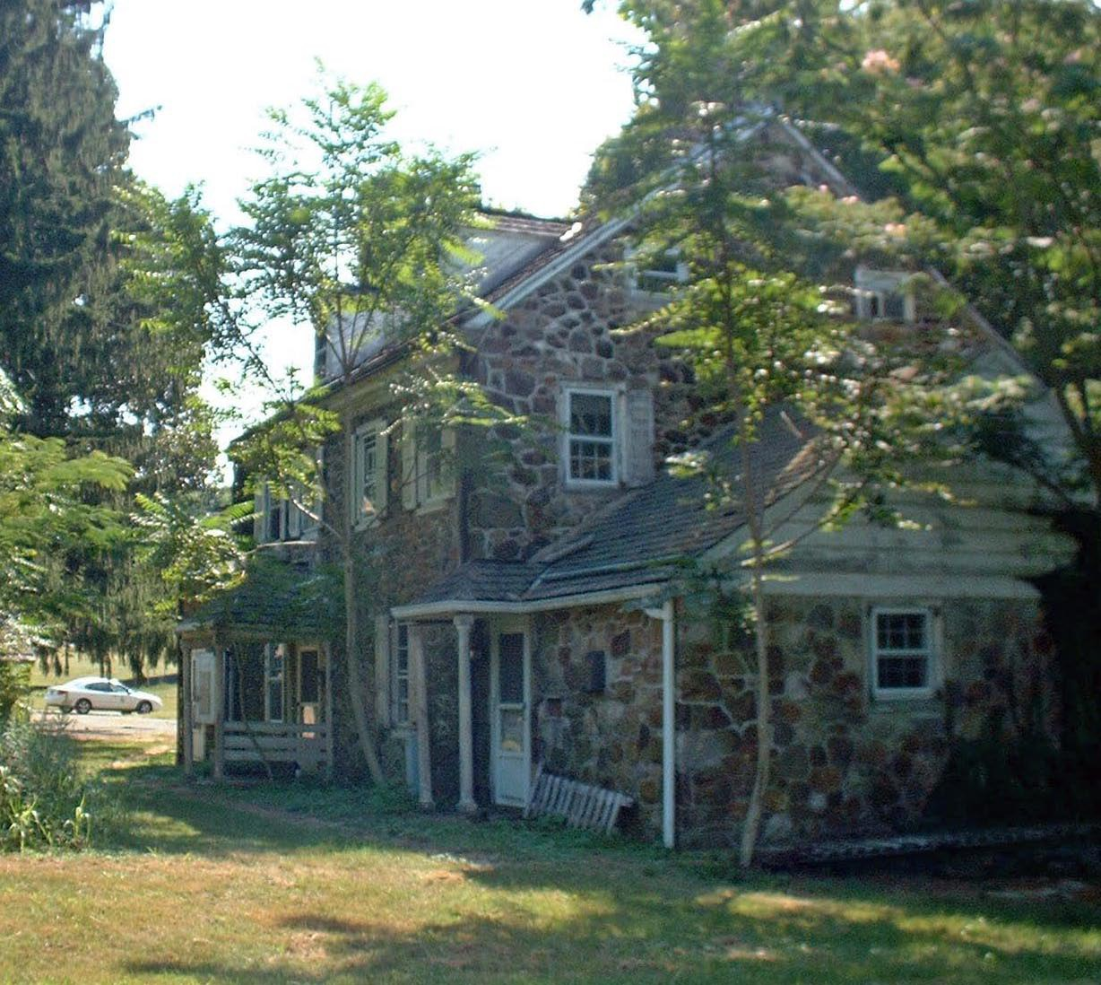

Glen Echo is a strikingly beautiful historical structure, but in poor condition. A new roof is required, extensive stone and pointing work is needed, electrical and mechanical systems need to be upgraded, and the kitchen needs to be substantially improved. In addition, extensive interior repairs and upgrades are required.

Present Use: Glen Echo is currently uninhabitable while awaiting conversion to a yet-undetermined use.

Disability Access: None

Past Projects:

Scheduled Projects or Capital Renovations: An expansion and restoration of this building was authorized by the Legislature in 2000 for $2,016,000 as a retreat/ conference center. Funding has never been pursued or approved.

Description of Construction: Masonry stone foundation, wood shingle roof, stone exterior wall with some wood siding, wood floors.

Condition and Use Assessment:
Deferred Maintenance (2007): $ 335,000 | Est Replacement Cost (2007): $ 600,000
Facility Condition Index: 0.56 | Deficiency/SF: $ 47.82
Yearly Electric Use Cost: $ | Yearly Water Use Cost $

