
Glen Echo Carriage House

844 S. New Street
Built: Late 1800’s | Size: 1,949 sf
Acquired: 1968 | Condition: Poor
Last Renovation: | Function: E&G

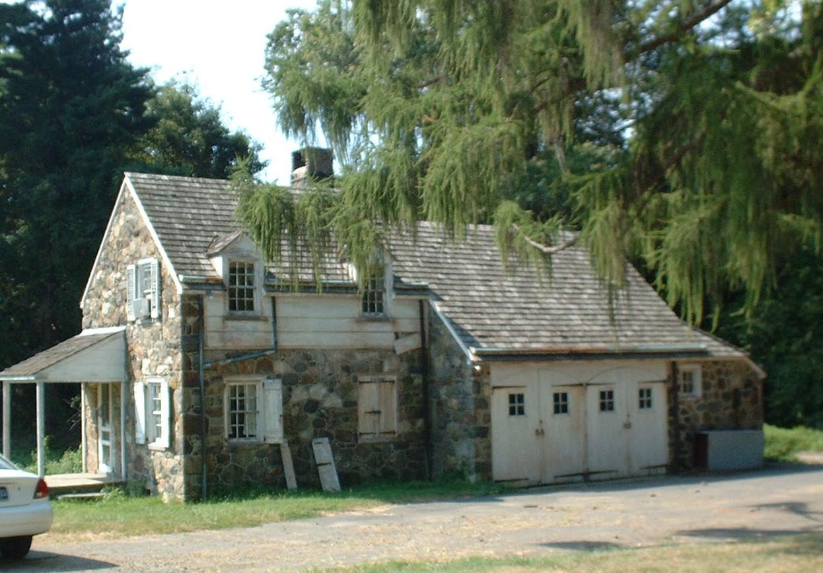

Extensive repointing and stone work are required, roof replacement is necessary, and the electrical and mechanical systems need to be upgraded.

Present Use: Glen Echo is currently uninhabitable while awaiting conversion to yet-undetermined use.

Disability Access: None

Past Projects:

Scheduled Projects or Capital Renovations: None

Description of Construction: Stone foundation, wood shingle roof, combination stone and wood siding, wood floors.

Condition and Use Assessment:
Deferred Maintenance (2007): $ 78,000 | Est Replacement Cost (2007): $ 300,000
Facility Condition Index: 0.26 | Deficiency/SF: $ 40.
Yearly Electric Use Cost: $ | Yearly Water Use Cost $

