
Graduate Business Center

1160 McDermott Drive
Built: 2002 | Size: 46,895 sf
Acquired: | Condition:
Last Renovation: | Function: E&G

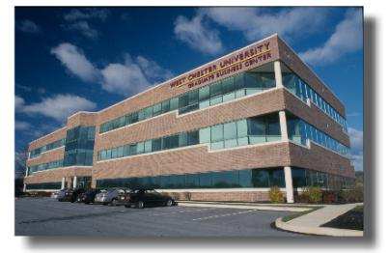

This three story office-grade structure lies north of Main Campus approximately 2 miles in an office park complex. The second floor of this building house none state-of-the-art electronic classrooms as well as two video conference facilities for the Graduate programs for the School of Business, while the third floor houses departmental offices for the College of Business and Public Affairs MBA and MSA programs, and the office of the Assistant Dean. A portion of the first floor houses Graduate College of Education offices and classrooms; the remaining first floor space is leased commercial office space. Staff offices, kitchen and dining areas are included in the attractive well designed and technologically advanced spaces.

Present Use: Classroom and faculty offices

Disability Access: Full

Past Projects: 2004 Graduate College of Education tenant fit out.

Scheduled Projects or Capital Renovations: None

Description of Construction: Concrete foundations, steel structure, flat roof, ribbon windows on brick curtain walls, concrete slab floors.

Condition and Use Assessment:
Deferred Maintenance (2007): $ 0 | Est Replacement Cost (2007): $ 11,018,000
Facility Condition Index: 0. | Deficiency/SF: $ 0
Yearly Electric Use Cost: $ | Yearly Water Use Cost $

