
701 S. High Street

701 S. High Street
Built: 1970 | Size: 9,000 sf
Acquired: 2005 | Condition: Good
Last Renovation: 2006 | Function: E&G

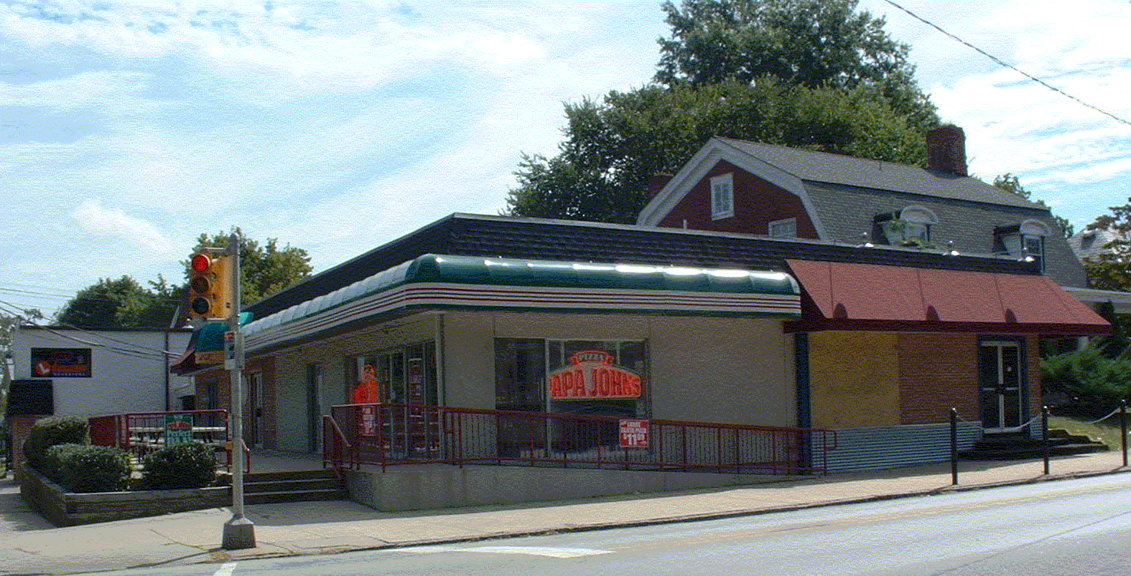

Purchased in 2005, this building’s first floor area is leased to two commercial retail businesses, while the basement has been converted from a bar into temporary-faculty office space. It’s location across from Main Hall has particular advantage over 220 E. Rosedale Ave as a location for temporary and adjunct faculty office space.

Present Use: Retail on first floor, Faculty Office space in basement.

Disability Access: 1st floor commercial space- 1st floor conference room only.

Past Projects: 2006 Roof & Basement area general renovation

Scheduled Projects or Capital Renovations: None

Description of Construction: Masonry block foundation, rubber roof on tectum deck, brick and stucco siding on block frame exterior wall, wood floors.

Condition and Use Assessment:
Deferred Maintenance (2007): $ 0 | Est Replacement Cost (2007): $ 2,320,000
Facility Condition Index: 0. | Deficiency/SF: $ 0
Yearly Electric Use Cost: $ | Yearly Water Use Cost $

