
Farrell Stadium

875 S. New Street
Built: 1970 | Size: 5,692 sf
Acquired: N/A | Condition: FAIR
Last Renovation: 2006 | Function: E&G

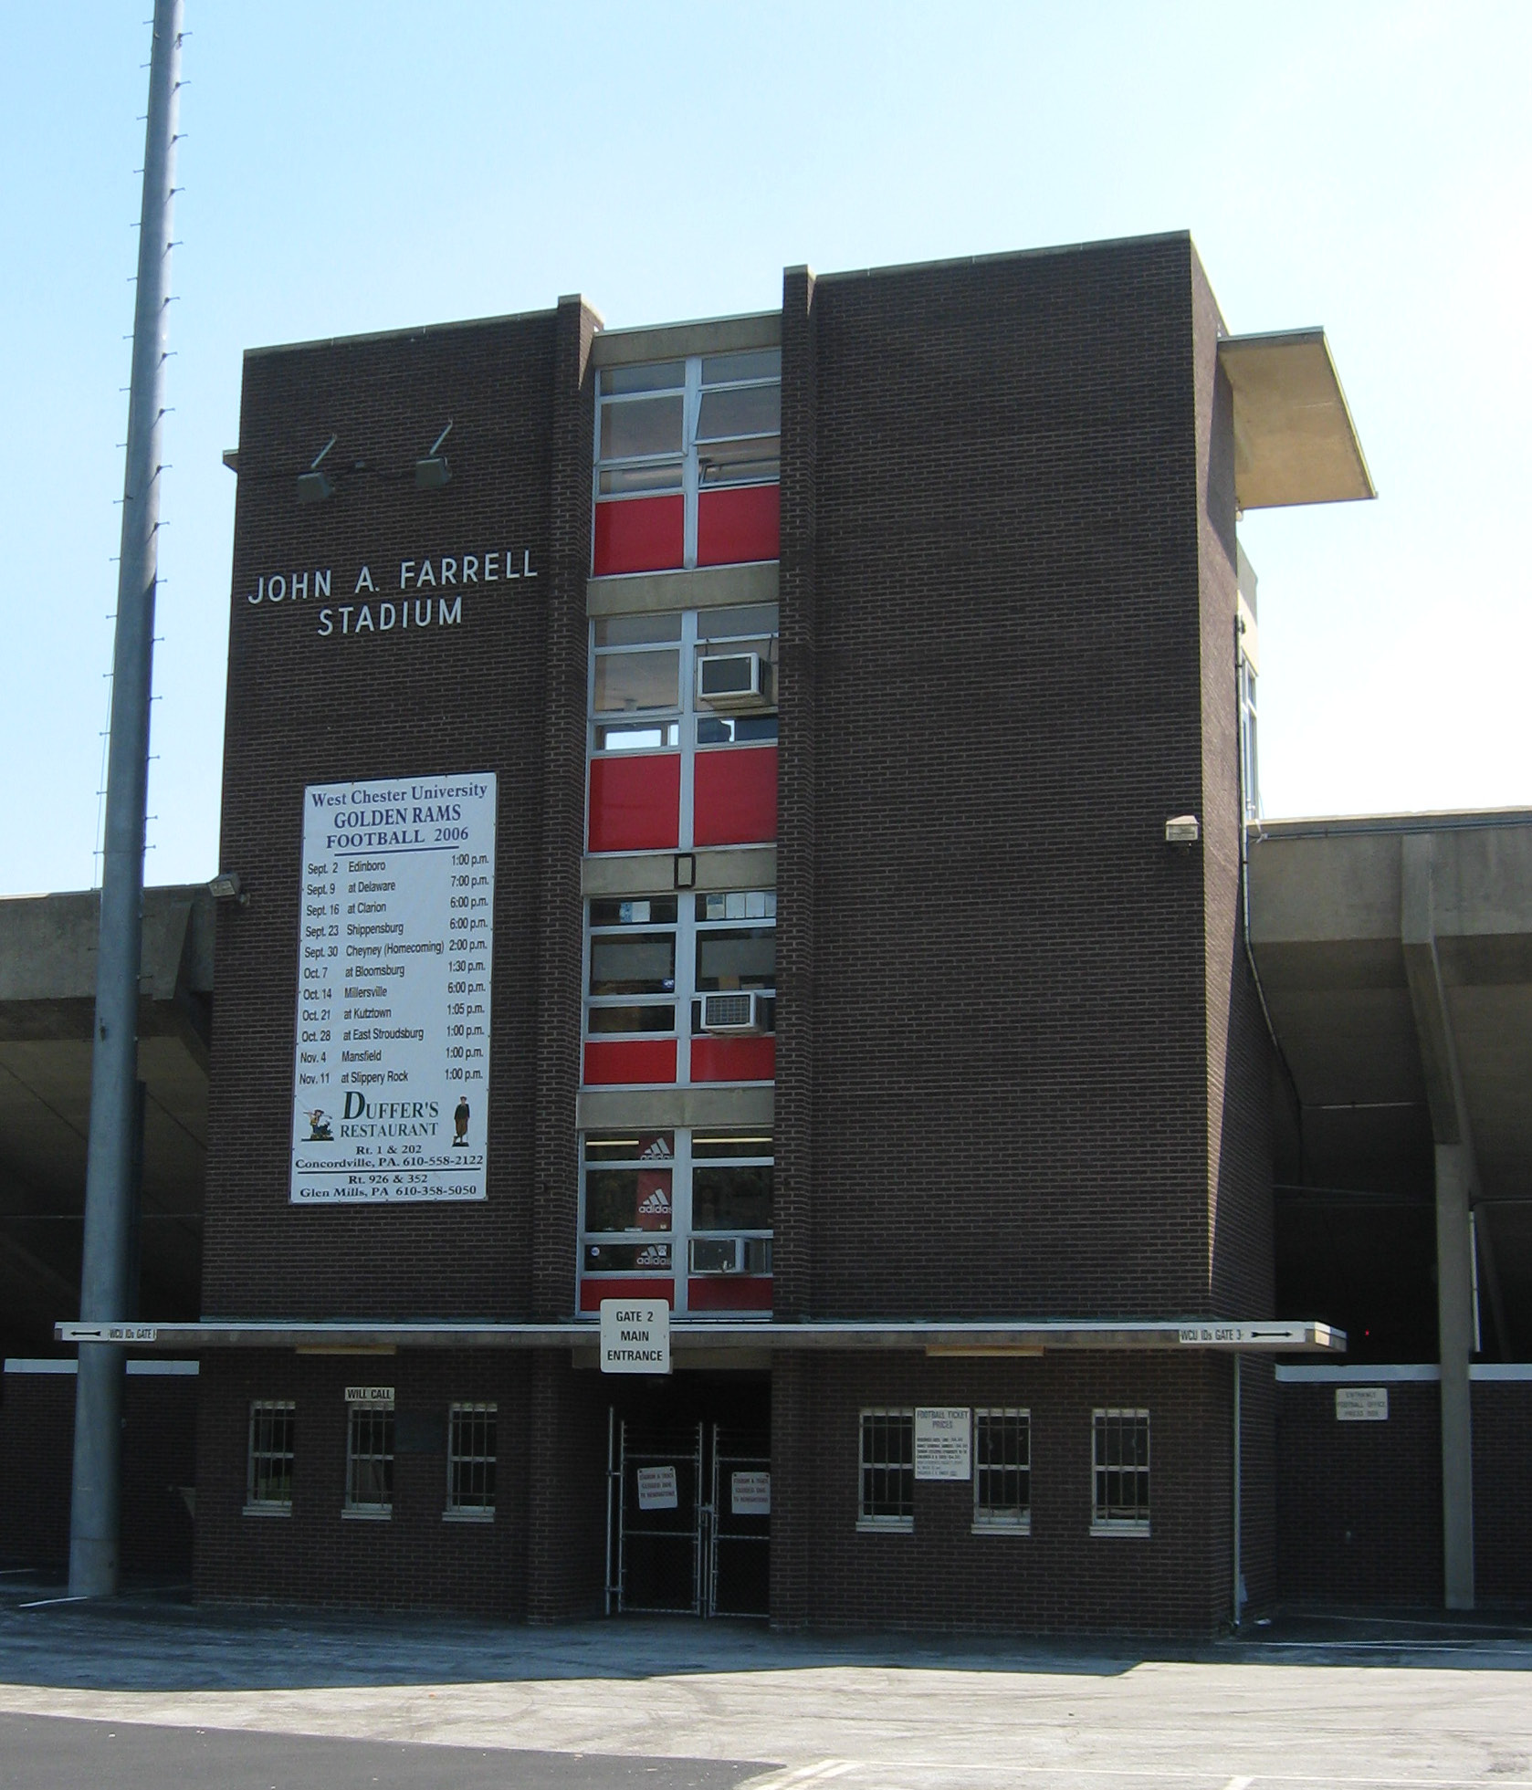

Farrell Stadium is in fair condition, with two sets of permanent bleachers and a viewing tower, with ticket booths, restrooms, offices, a press box, and a TV room. The track was upgraded in 1989, resurfaced in 1995, and completed rebuilt in 2006. Bathrooms were upgraded in 1997. A Field lighting system, installed for night games, was upgraded in 1999. The stadium has limited handicapped accessibility and is in need of structural repair.

Present Use: Athletic stadium and offices

Disability Access: Home side ADA Seating accessible by ramp, Accessible bathrooms, accessible parking. All other aspects of stadium inaccessible.

Past Projects: 1989 Track Upgrade, 1995 Track Resurface, 1997 Bathrooms, 1999 Lighting, 2004 Asphalt walkway repairs, 2005 Audio System Upgrade and roof replacement, 2006 New Artificial Turf Field and renovated Track.

Scheduled Projects or Capital Renovations: None

Description of Construction: Reinforced concrete foundation, built-up roof, masonry brick veneer exterior walls, concrete slab floors.

Condition and Use Assessment:
Deferred Maintenance (2007): $ 335,000 | Est Replacement Cost (2007): $ 1,240,000 (Bldg only)
Facility Condition Index: 0.27 | Deficiency/SF: $ 58.85
Yearly Electric Use Cost: $ | Yearly Water Use Cost $

