
Ehinger Gym

700 S. Church Street
Built: 1930 | Size: 13,675 sf
Acquired: N/A | Condition: Poor
Last Renovation: | Function: E&G

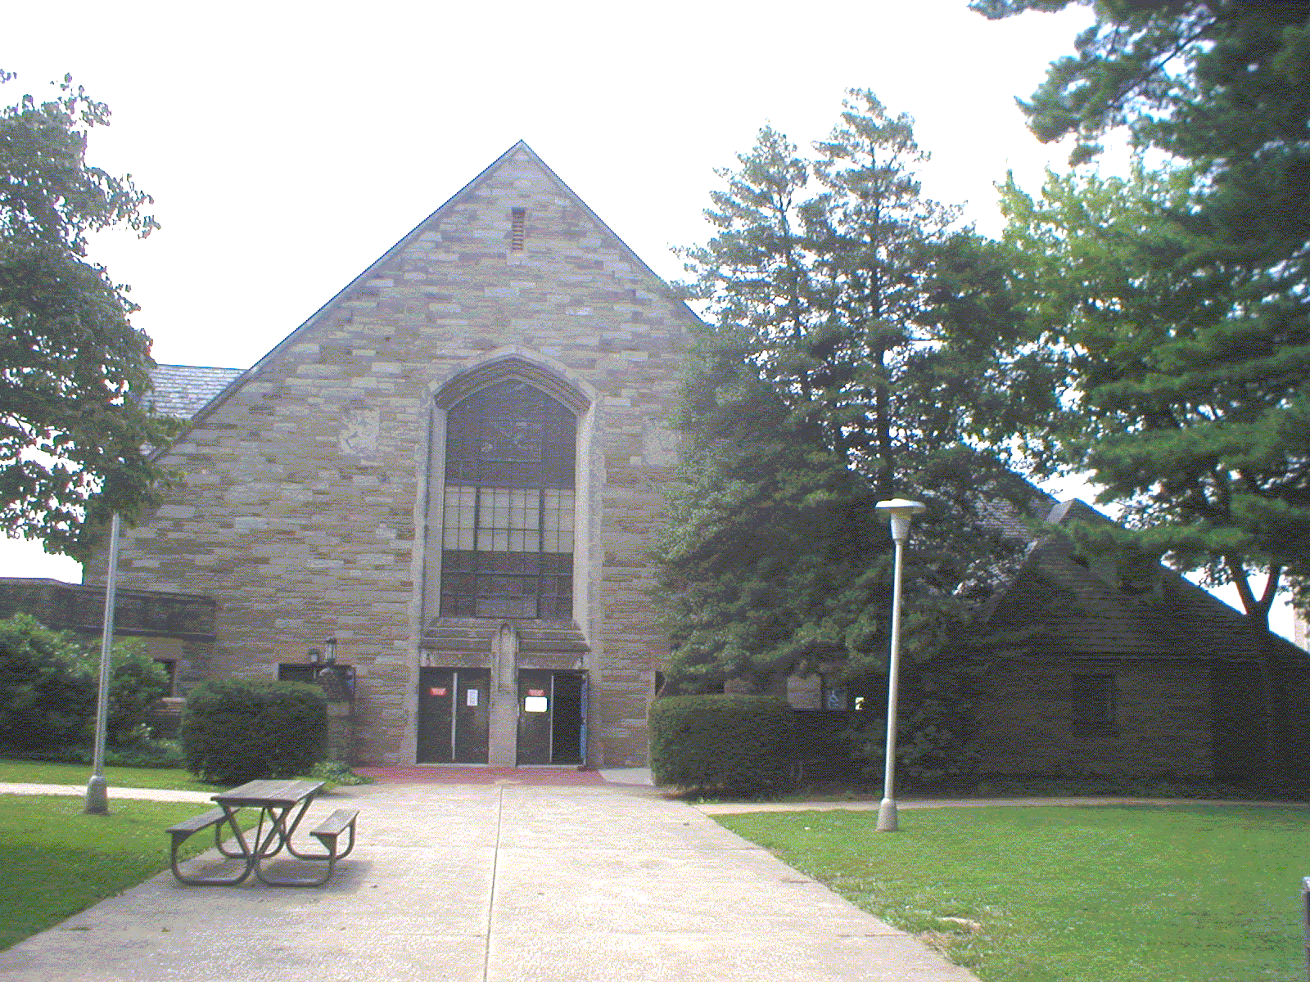

Ehinger Gymnasium is located on the corner of South Church Street and University Drive. The back of the gymnasium joins with Hollinger Field House. Extensive renovations are required to bring this building up to current code, and to support the heavy use by students.

Present Use: Supports athletic, recreational and social activities.

Disability Access: Full, with exception of lower level locker rooms. Main level accessible locker rooms are available.

Past Projects: 1998, Gym Floor replacement, 2001 Roof

Scheduled Projects or Capital Renovations: None- A $5.8 million project renovation was authorized by the Legislature in 2000, but never funded.

Description of Construction: Reinforced concrete foundation and structure, built-up roof, masonry brick veneer exterior walls, concrete slab floors.

Condition and Use Assessment:
Deferred Maintenance (2007): $ 450,000 | Est Replacement Cost (2007): $ 3,063,000
Facility Condition Index: 0.147 | Deficiency/SF: $ 32.90
Yearly Electric Use Cost: $ | Yearly Water Use Cost $

