
Chemical Storage Bldg.

105 W. Rosedale Avenue
Built: 1994 | Size: 1,183 sf
Acquired: N/A | Condition: Good
Last Renovation: | Function: E&G

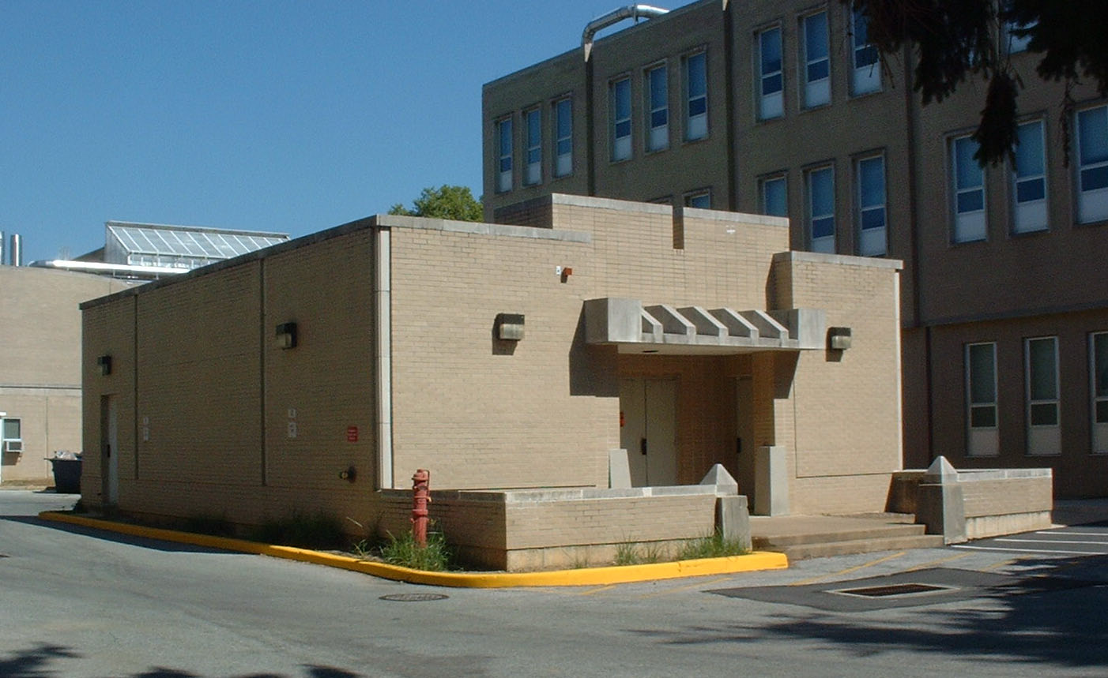

This facility was constructed to serve the chemical storage needs of the science complex. It is currently fully sprinklered.

Present Use: Chemical storage

Disability Access: None

Past Projects:

Scheduled Projects or Capital Renovations: None

Description of Construction: Concrete floor and foundation, brick exterior wall, composition roof with explosion panels.

Condition and Use Assessment:
Deferred Maintenance (2007): $ 0 | Est Replacement Cost (2007): $ 283,000
Facility Condition Index: 0. | Deficiency/SF: $ 0
Yearly Electric Use Cost: $ | Yearly Water Use Cost $

