
201 Carter Drive

201 Carter Drive
Built: 1983 | Size: 50,600 sf
Acquired: 1991 | Condition: Good
Last Renovation: 1998- Suite 300 & 400; 2001- Suite 200 | Function: E&G

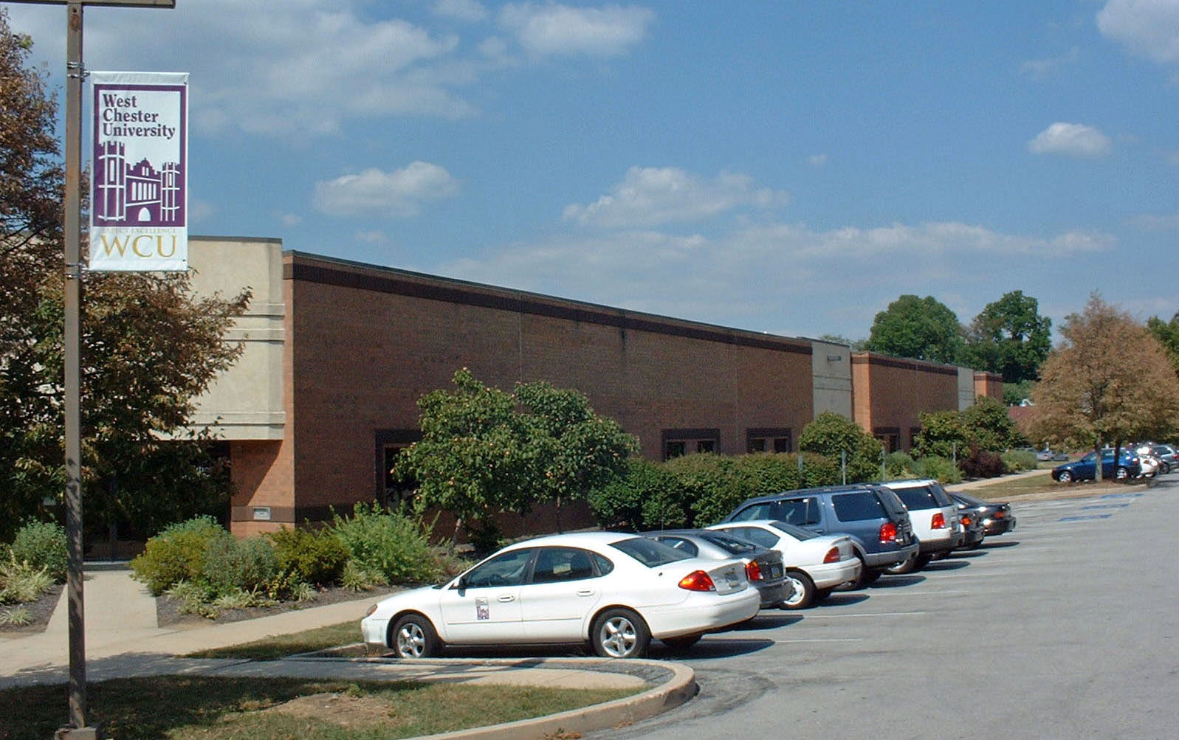

This 50,600 sq. ft. facility was purchased by the University from a local developer in June 1991.

Present Use: Facilities Division office space; Physical Plant office/ shop space; Theatre Arts Shop, Human Resource/Payroll/ Environmental Health and Safety office space; Speech & Hearing Clinic, Communicative Disorders Department, Fiscal Affairs, Budget Office, Internal Review Office, and Business Services Offices.

Disability Access: Full (one story)

Past Projects: Build-outs to Suites 200 (2002) , 300 and 400 (1993). Plumbing shop mezzanine (2001).

Scheduled Projects or Capital Renovations: None

Description of Construction: Concrete foundation and floors, brick exterior walls, two-ply roof.

Condition and Use Assessment:
Deferred Maintenance (2007): $ 300,000 | Est Replacement Cost (2007): $ 10,889,000
Facility Condition Index: 0.027 | Deficiency/SF: $ 5.81
Yearly Electric Use Cost: $ | Yearly Water Use Cost $

