
Bayle House

703 South High Street
Built: 1930s | Size: 3,000 sf
Acquired: 2005 | Condition: Good
Last Renovation: 2006 | Function: E&G

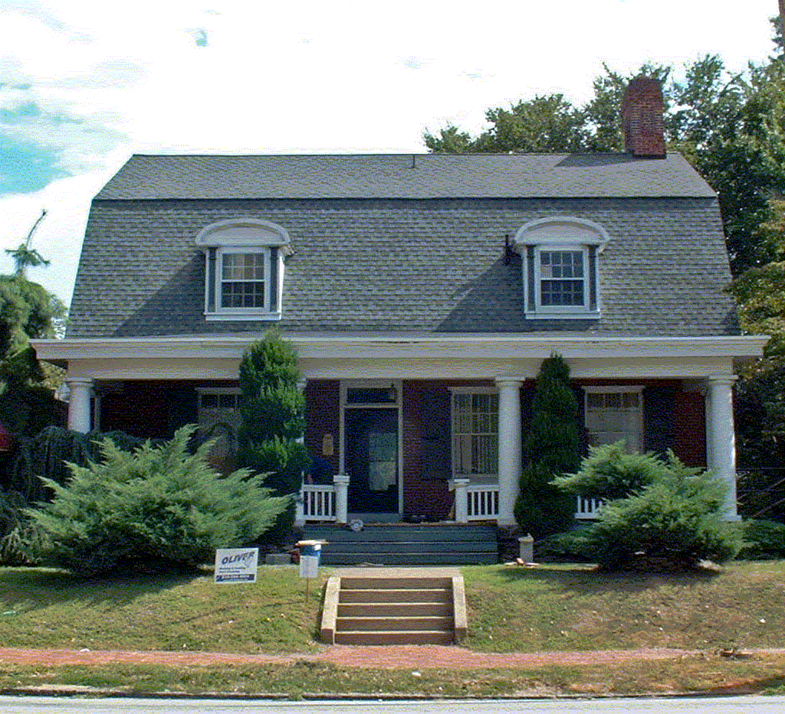

Purchased in 2005, this building is presently under conversion for two campus departmental offices.

Present Use: Office space for 3E Institute and Honors College

Disability Access: 1st floor only thru ramp at front entrance- accessible parking in rear.

Past Projects: General renovation for occupancy 2006.

Scheduled Projects or Capital Renovations: None

Description of Construction: Stone foundation, wood framed house with brick façade and wood siding. Asphalt shingle roof.

Condition and Use Assessment:
Deferred Maintenance (2007): $ 0 | Est Replacement Cost (2007): $ 634,000
Facility Condition Index: 0. | Deficiency/SF: $ 0
Yearly Electric Use Cost: $ | Yearly Water Use Cost $

