
850 S. New Street

850 S. New Street
Built: | Size: 6,235 sf
Acquired: 1994 | Condition: Good
Last Renovation: 1999 | Function: E&G

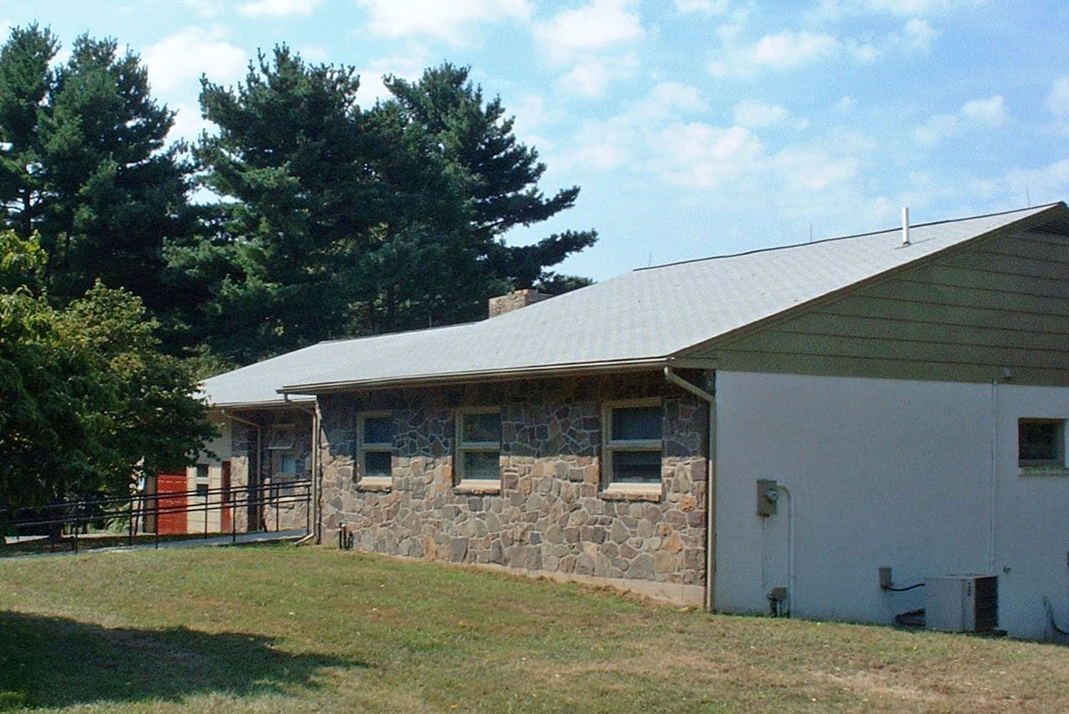

This property is within a residential zone in East Bradford Township.

Present Use: Athletic Department coaches offices. The property is in good shape, after a recent renovation.

Disability Access: 1st floor only (no elevator). Ground floor access can be made thru rear sliding doors, with assistance.

Past Projects: 1999 General Renovation, Roof

Scheduled Projects or Capital Renovations: None

Description of Construction: Two story ranch house, concrete slab, wood frame construction, wood roof with asphalt shingles, masonry foundation.

Condition and Use Assessment:
Deferred Maintenance (2007): $ 0 | Est Replacement Cost (2007): $ 1,322,000
Facility Condition Index: 0. | Deficiency/SF: $ 0
Yearly Electric Use Cost: $ | Yearly Water Use Cost $

