
Anderson Hall

725 S. Church Street
Built: 1938 | Size: 88,189 sf
Acquired: N/A | Condition: Excellent
Last Renovation: 1994 | Function: E&G

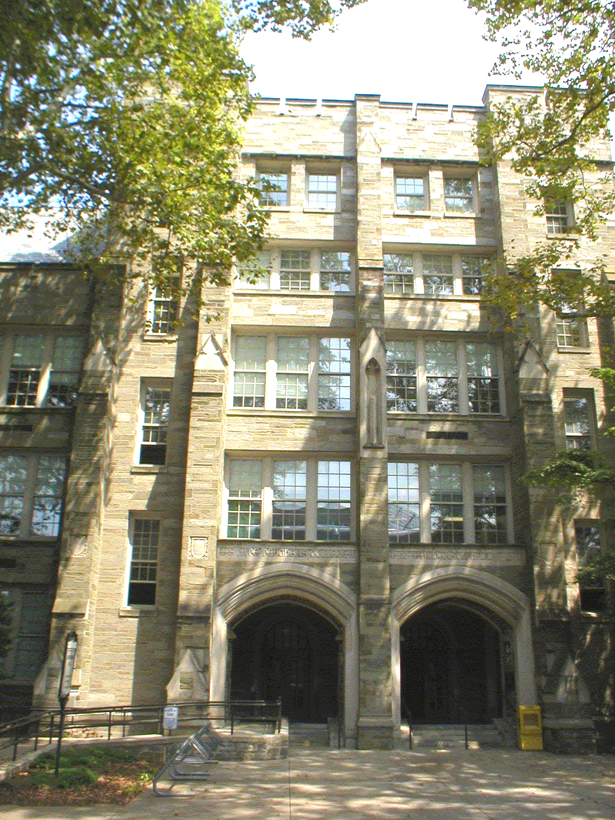
Anderson Hall, in the heart of the campus, marks the western border of the Quad along South Church Street. Originally built in 1938 by Philadelphia Architect Zantzinger and Borie, it stands today as one of the architectural gems of West Chester University and the Borough of West Chester.

Anderson Hall is the University’s largest classroom facility. In addition to 27 general-purpose classrooms, Anderson Hall has the Academic Computing Center with 9 labs and over 200 computers on the ground floor, printer stations, mathematics manipulative lab, 2 Computer Sciences department labs, 2 computer labs with Macintosh and Apple computers on the first floor, and the GIS lab. The Academic Computing Center is the main general access open campus computing lab for all students.

The building is in excellent condition after numerous renovation projects, including a new slate roof in 2006.
Present Use: Classrooms and faculty/staff office space. Office space for the Vice President for Information Services and the academic computing center. Academic departments include math, computer science, accounting, economics, marketing, management, and geography and planning.

Disability Access: Full, with exception of third floor faculty offices.

Past Projects: 1993 Roof, 1994 Life-cycle Renovation, 1995/99 A/C Upgrades, 1997 Catwalk & UPS, 1999 Life Safety Structural Repairs, 1999 DDC Upgrade, 2002 Roof drainage repair, 2002 Telecom closet, 2006 Slate Roof, 2007-2008 HVAC upgrades.

Scheduled Projects or Capital Renovations: None

Description of Construction: Reinforced concrete foundation, slate shingle and built-up roof, masonry stone veneer exterior walls, concrete floors.

Condition and Use Assessment:
Deferred Maintenance (2007): $ 0 | Est Replacement Cost (2007): $ 22,280,000
Facility Condition Index: 0. | Deficiency/SF: $ 0
Yearly Electric Use Cost: $ | Yearly Water Use Cost $

