
Alumni House

101 Norfolk Avenue
Built: 1906 | Size: 2807 sf
Acquired: 1995 | Condition: Good
Last Renovation: 1996 | Function: E&G

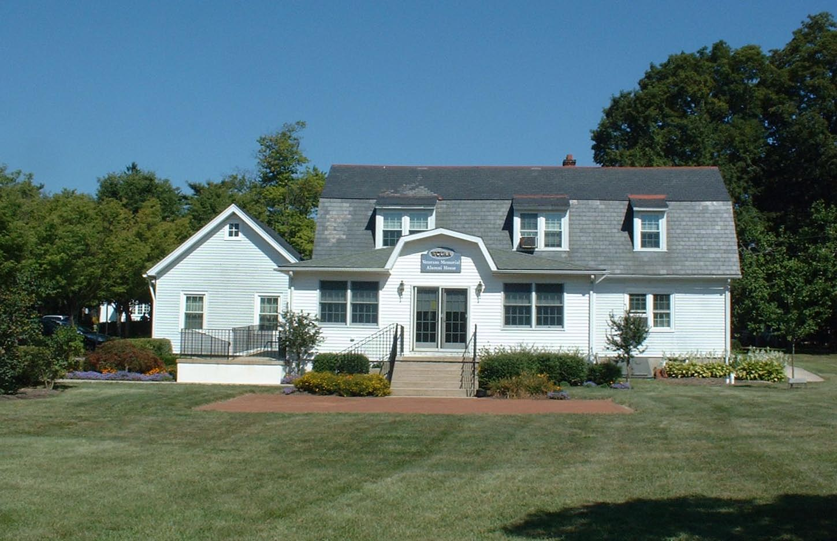

The Alumni House is owned by the Alumni Association. The University leases 697 square feet to house the Alumni Relations Staff. An addition in the rear of the building, funded totally by the Alumni Association, has recently been completed, adding a quality meeting room to their assets. This room and others are and will be used several times each week by various University departments for official meetings and receptions.

Present Use: Alumni offices, meeting/fundraising space.

Disability Access: 1st floor only, thru a ramp at the rear (Main) entrance. Accessible restroom.

Past Projects: Renovations for occupancy as meeting rooms, offices.

Scheduled Projects or Capital Renovations: None

Description of Construction: Wood frame, two-story house on concrete slab, partial basement, asphalt shingle roof.

Condition and Use Assessment:
Deferred Maintenance (2007): $ 0 | Est Replacement Cost (2007): $ 575,000
Facility Condition Index: 0. | Deficiency/SF: $ 0
Yearly Electric Use Cost: $ | Yearly Water Use Cost $

