
13/15 University Ave

Built: 1920s | Size: 8,340 gsf
Acquired: 1985/ 1988 | Condition: Fair
Last Renovation: 1989 | Function: E&G

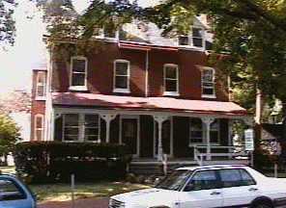

13/15 University Avenue is well located for administrative use. It is handicapped accessible, however, extensive renovation work is required to bring it into full compliance with ADA and prevailing codes. Originally scheduled for demolition for siting of the planned Business Center, it is now slated to remain intact, with the Business Center site now located in M Lot, adjacent to the new Swope Music Building and the Performing Arts Center. Ample parking can be found adjacent at B Lot.

Present Use: Office space: Office of Cultural Affairs, Phon-a-thon Room, Advancement Division, Social Equity Department, Publications and Printing Services, Public Relations and Marketing.

Disability Access: 1st floor only thru front ramp. No elevator

Past Projects: General renovation into office space and roof repairs in 1989.

Scheduled Projects or Capital Renovations: none

Description of Construction: Masonry block foundation, asphalt shingle roof, brick and wood siding on wood frame exterior wall, wood floors.

Condition and Use Assessment:
Deferred Maintenance (2006): $ 110,000 | Est Replacement Cost (2007): $1,769,813
Facility Condition Index: 0.062 | Deficiency/SF: $ 13.19
Yearly Electric Use Cost: $ | Yearly Water Use Cost $

